Name:
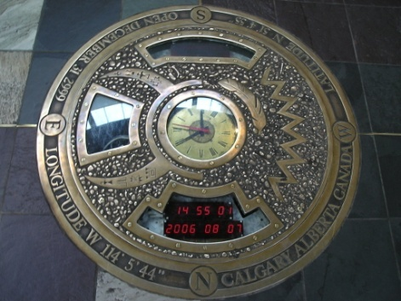

What Will Our Legacy Be?

You have been asked to fill a time capsule with at least five objects to be opened 300 years from now. You should choose objects that best symbolize our culture and society of 2015. Include a rationale (justification, grounds, raison d'être, validation, basis, reason) that explains how that item fits and why it is one of the best items for the capsule. Be specific!!

Tips:
    - The time capsule can be any size, so items can range from a ball to a building.
    - Consider things that make America unique, and include items that best represent the uniqueness.
    - Think of good/bad parts of our society, successes/failures, etc, and come up with objects that symbolize those ideas.
    - We don’t condone killing for the time capsule, so no human bodies. Pictures of humans are fine.

Object 1:
Rationale:

Object 2:
Rationale:

Object 3:
Rationale:

Object 4:
Rationale:

Object 5:
Rationale:
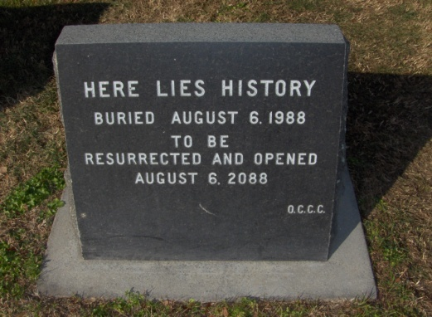

Anything Else?

