Name # Class Period Date
Take Home Test: Absolutism, Enlightenment, & The Age of Revolutions
Read ALL directions very carefully!
Part I- Matching
Directions: Match the person with the correct description of their beliefs. Fill your answer into the gray box
A. Montesquieu
B. Voltaire
C. Wollstonecraft
D. Rousseau
E. Smith
F. Locke

- natural rights; responsible government
- social contract; freely elected government; common good
- freedom of speech
- separation of powers
- women’s rights
- laissez-faire economics, little or no government regulation of business

A. Declaration of the Rights of Man
B. Congress of Vienna
C. bourgeoisie
D. estate system
E. Tennis Court Oath
F. guillotine

- The wealthiest members of the Third Estate (middle class)
- The vow of the 3rd Estate to continue meeting until a new constitution was produced
- class structure / social order before the French Revolution
- meeting after the fall of Napoleon during which European leaders redrew the map of Europe and restore balance of power
- document written during the French Revolution that stated all men enjoy the natural rights to “liberty, property, security, and resistance to oppression.”
- represented the idea that all men were equal in death

Part II Matching

a. Otto von Bismarck
d. Giuseppe Garibaldi
b. Camillo Cavour
e. Wilhelm I
c. Victor Emmanuel II

- first emperor of united Germany
- Prime minister of Sardinia who helped to unite Italy
- Prussian prime minister responsible for German unification
- first king of united Italy
- Italian nationalist whose Red Coat army conquered southern Italy and turned it over to Sardinia

Anatomy of a Revolution

Author Crane Britton proposed a theory that many of the world’s revolutions follow a distinct pattern. Below, you will find a brief outline. Read through this carefully, and then answer the questions that follow. READ very carefully.

On the eve of revolution, the government has failed to meet the needs of the people, has denied political power to new and powerful social or economic groups, and has lost the support of the intellectuals.
The revolution begins with a dramatic act that demonstrates the inability of the government to control the course of events.
The moderates in the revolutionary movement seize power and attempt a program of moderate reform.
The moderate reform program arouses opposition and violence by counter-revolutionary forces within the country and by fearful foreign countries.
To preserve the revolution in this “crisis stage”, the extremists of the revolutionary movement seize control and employ force and terror against enemies of the revolution.
With the crisis surmounted and the public sick of the bloodletting, the terror comes to an end.
In the ensuing period of political instability, a powerful leader emerges, seizes power, and rules as a dictator. The public acceptance of the dictator is based on the belief that he will preserve some of the gains of the revolution while at the same time providing political stability and social cohesion.

Choose the event that best fits each stage of the French Revolution.

- On the eve of revolution the government has failed to meet the needs of the people has denied political power to new and powerful social or economic groups and has lost the support of the intellectuals.
- Spending of the monarchy takes a toll on the French economy
- The Third Estate is locked out of the Estates General and vow to meet until a new constitution is written
- Enlightenment ideals question the absolute power of the government
- a & b
- All of the above

- The revolution begins with a dramatic act that demonstrates the inability of the government to control the course of events.
- The Bastille prison is stormed
- The church is reorganized, taking power away from the 1st Estate
- The 1st and 2nd Estates join the 3rd Estate in the National Assembly
- Delegates of the Estates General take the Tennis Court Oath

- The moderates in the revolutionary movement seize power and attempt a program of moderate reform.
- The monarch is abolished and Louis XVI is put in prison
- The women of Paris march on Versailles to demand bread
- The Girondists write The Declaration of the Rights of Man and establish a Constitutional Monarchy
- Louis XVI calls the Estates-General for the first time in more than 100 years to solve the economic crisis

- The moderate reform program arouses opposition and violence—by counter-revolutionary forces within the country and by fearful foreign countries.
- The sans-culottes (“working class”) demand a republic over a constitutional monarchy
- Austria and Prussia declare war on France
- The Jacobin political party gains power in the Legislative Assembly

- I, III
- I, II
- II, III
- I, II, III

- To preserve the revolution in this “crisis stage”, the extremists of the revolutionary movement seize control and employ force and terror against enemies of the revolution.
- Panic known as “The Great Fear” spreads through the country-side of France
- France declares war on Great Britain to counter-act their anti-revolutionary forces
- The Committee of Public Safety is formed
- Louis XVI is executed for treason against the French people

- With the crisis surmounted and the public sick of the bloodletting, the terror comes to an end.
- Louis XVI and Marie Antoinette successfully flee from Paris
- Marat, author of revolutionary newspaper The People’s Friend, is murdered in his bathtub
- The National Assembly is established as the French legislative body
- Robespierre is executed by the guillotine

- In the ensuing period of political instability, a powerful leader emerges, seizes power, and rules as a dictator
- Robespierre and the Committee of Public Safety begin “the Great Terror” in the name of virtue
- The Directory is established
- The royal line is reestablished with Louis XVIII (18th).
- Napoleon Bonaparte leads a coup d’état against the French government

Multiple Choice

- How did the guillotine reflect Enlightenment ideas?
- It was quick and painless (we think at least….)
- Everyone, regardless of social class, was executed the same way
- It eliminated the need for a fair trial

  - I only
  - II & III
  - I & II
  - All three

- During the Scientific Revolution and the Enlightenment, what was a similarity in the work of many scientists and philosophes?
a. they agreed with medieval thinkers c. they favored an absolute monarchy
b. they received support from the Catholic Church d. they thought about the world in a new way

- Why should citizens be the authors of society’s laws, according to the quote from Rousseau?
“I…therefore give the name ‘Republic’ to every state that is governed by laws, no matter what the form of its administration may be: for only in such a case does the public interest govern, and the res republica rank as a reality...Laws are, properly speaking, only the conditions of civil association. The people, being subject to the laws, ought to be their author: the conditions of the society ought to be regulated…by those who come together to form it.”
--Jean Jacques Rousseau, The Social Contract
a. They are the ones who will be required to obey the laws.
b. Rulers are always corrupt and misguided.
c. The laws will be more lenient if the people create them.
d. Rulers are too out of touch with public interest.

- Which speaker’s statement best reflects the ideas of the Enlightenment?
- Speaker A: Good government stresses the importance of the nation instead of the rights of the individual.
- Speaker B: The person of a king is sacred and to attack him is to attack religion itself.
- Speaker C: All human beings are born free and equal with a right to life and liberty.
- Speaker D: Our goal will not be achieved by democracy or liberal reforms, but by blood and iron.
- How was the Haitian Revolution different from the other revolutions in Latin America?

a. it was fought against the Portuguese
b. it established a constitutional monarch
c. it was initially a slave revolt
d. it involved Napoleon Bonaparte
- Who earned the nickname “The Liberator of Latin America”?

A. Simón Bolívar
B. Napoleon Bonaparte
C. Toussaint L'Ouverture
D. Jose de San Martin

- “Congress of Vienna Restores Monarchy to France”
“Czar Nicholas I Limits Freedom of the Russian Press”
“Reform Movements Crushed in Hungary, Italy, and the German States”

Which of the following categories could you group the above headlines into?
a. reactions to the French Revolution
b. movements to unify all of western Europe
c. efforts to improve the conditions of factory workers
d. attempts to promote trade between European nations

- What does the political cartoon below suggest about the Third Estate?
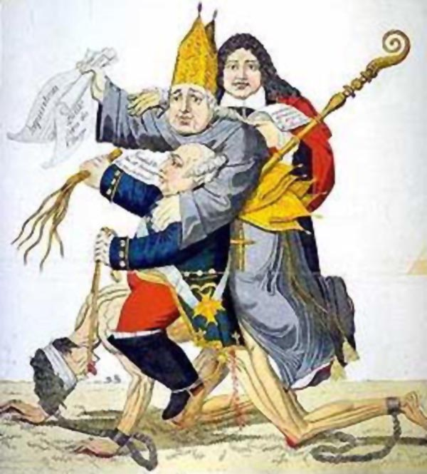
a. They were happy with their position in France
b. They were slaves to the First and Second Estate
c. They had more wealth and power than the other two estates.
b. They believed that you should support the king because he was appointed by God

- What was the actual result of the Congress of Vienna?
a. The ideals of revolution were preserved in France
b. Prussia and Austria gained more land and power
c. Nationalist fervor was encouraged throughout Europe
d. A successful peace was created in Europe

- “A Country is not a mere territory; the particular territory is only its foundation. The Country is the idea which rises upon that foundation; it is the sentiment of love, the sense of fellowship which binds together all the sons of that territory.”— Giuseppe Mazzini

What idea does this quotation support?
a. imperialism c. radicalism
b. nationalism d. militarism

- Which of these were results of the Franco-Prussian War?
i. Germany is united
ii. France overthrew their government
iii. The Austrian empire crumbled
iv. Bismarck was thrown out of power
v. Wilhelm I is crowned Kaiser of Germany

a. i, iii, v
b. i, ii, iv
c. i, v
d. iv, v
e. All of these

Short Answers
You need to answer ALL of the following questions

- The Enlightenment was an intellectual, cultural, social, and philosophical movement that spread through Europe during the sixteenth century. Explain two effects of the Enlightenment on the world.

- Discuss the relationships between the American, French, and Latin American Revolutions.

- What was the effect of Nationalism on Europe? In particular, think about the unifications of Italy and Germany.

