Study Guide
Renaissance, Reformation, Exploration, Absolute Monarchy
- What do humanists believe about human achievement?
- What ancient group influenced the people of the Renaissance?
- Where did the Renaissance begin and why?
- How did art change during the Renaissance?
- What is the Renaissance seen as the beginning of?
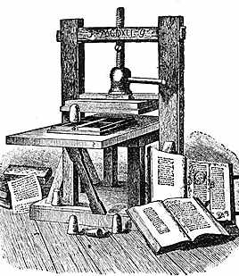
- How do the following represent humanism?
School of Athens, Raphael
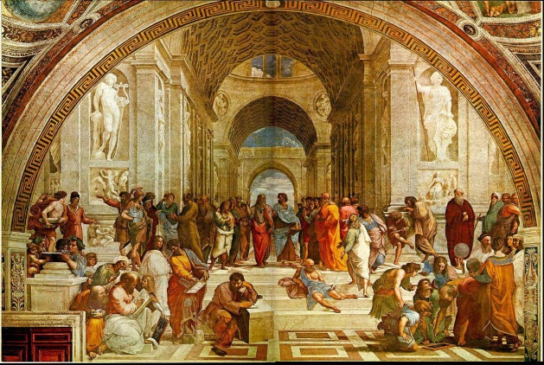
Printing Press

What piece of work is a man! how noble in reason! how infinite in faculty! in form and moving how express and admirable! in action how like an angel! in apprehension how like a god! the beauty of the world! the paragon of animals!
~William Shakespeare, Hamlet, Act II, Scene II

- What did The Courtier describe?
- What type of people were painted in Northern Renaissance work?
- What was Martin Luther’s main argument in the 95 Thesis?
- Why did Luther’s protest spread so rapidly in Europe?
- What do the Catholics believe about the pope?
- What did Protestants believe about the Bible?
- Which was the result of the Reformation?
- Why did Henry VIII reform the Catholic Church?
- Why did Henry VIII marry so many times?
- Who led England through the Renaissance and their Golden Age?
- What are indulgences?
- What was the War of the Roses?
- Match the explorers with what they were looking for or their accomplishments:
a. Searching for the NW Passage | b. Spanish Conquistadors | c. Circumnavigated the Globe
d. Explored routes to India for Portugal | e. Founded North American colonies
- _____ Bartholomew Dias, Vasco de Gama, Pedro Cabral
- _____Francisco Pizarro, Hernando Cortez, Coronado, Ponce de Leon
- _____Henry Hudson, Jacques Cartier, Samuel Champlain
- _____Ferdinand Magellan, Sir Francis Drake
- _____Puritans, John Smith
- Where were Europeans trying to go at the beginning of the Age of Exploration?
- Where did Columbus believe he had landed?
- Which sailor led prestige missions for China?
- The transfer of foods, diseases, and human beings among Europe, the Americas, and the rest of the world that began during the Age of Exploration is known as
- Which Native American group lived in modern day Mexico?
- Which Native American group declined and abandoned their cities before Spanish explorers landed in Meso-America?
- Which Native American group had complex writing and calendars?
- Which Native American group used llamas?
- What three main areas of the world were connected by the triangular trade?
- What crop was most desired from the America in Europe?
- What was the name for the passage between Africa and America for slaves?
- What were conditions like on slave ships?
- Which colony had the highest slave population?
- What did Philip II do to increase Spain’s power? What was his downfall?
- How did Louis XIV ensure he had absolute power over the nobles in France?
- What was successful in Louis XIV’s reign? Unsuccessful?
- What did Charles I do to enrage the English Parliament? What was the result of this?
- What was the British Restoration? Glorious Revolution?
- What was the main cause of the Thirty Year’s War?
- What two countries fought during the War of Austrian Secession and who were their monarchs?
- What did Peter the Great do to modernize Russia? Catherine the Great?

