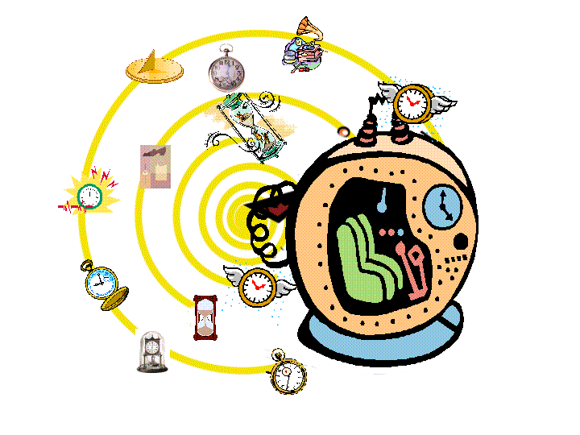
After years of research, you have finally managed to create a time machine!
Unfortunately, you can’t really control it.
On your first test run, you set it to travel only 130 minutes into the past.
After a few minutes of whirring noises, your machine comes to a stop, and you step out, and it’s not quite what you expected…
Your eyes have trouble focusing at first, but when they do, you realize the massive structure is definitely NOT from the 21st Century
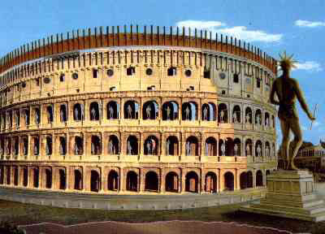
Before you fully comprehend the mistake you’ve made, two men dressed in bronze armor seize you by the arms and take you to a marble villa. Inside, there are hundreds of people dressed in white robes with red sashes.
In the center of the room is a large throne. The man sitting on it is more richly dressed in silks than those around him. He is middle aged and muscular with a closely cropped curly beard. One of the guards goes over to him and whispers something into his ear. The man’s eye widen with shock. He summons for a piece of parchment and pen, and spends several minutes in silence writing. He rolls up the scroll and gives it to a servant. Only the does he begin to speak aloud, and you are secretly are grateful for your high school Latin.
"I, Caesar Hadrian proclaim you a servant of the Emperor. You, stranger, have come to Rome with your unusual machine. I see from your clothing that you must be a foreigner and are perhaps sent by the gods. I have a task for you.”

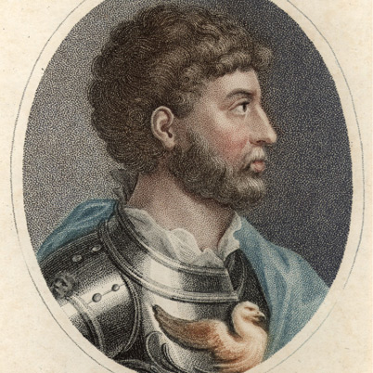
With a motion of Hadrian’s hand, the young servant rushes forward and hands you a scroll containing the task that Hadrian is setting to you. You unroll it to find the document below (translated now into English):

For the Glory of Rome
You are to create a document which shall proclaim to all future generations of the glory of Rome.
Explore the Eternal City of Rome and speak to our people that you might collect the information in this scroll. Then, you are to compile this information in a way in which the achievements of this great empire shall be known to all people.
You shall need your brains and your technology granted by the gods in order for you to complete this task.

By order of Caesar Publius Aelius Traianus Hadrianu
130 AD
Name # Class Period Date

First you are to explore the city of Rome through this virtual tour. Write down 10 sites that you see. Choose two of the sites and look up the basic info on them ( ie: why they were built, who built them, their purpose, etc)

Site 1:

Site 2:

Hadrian’s Wall
- Where Hadrian’s Wall built and what was its purpose?

- What engineering achievements were used to build this wall?

The Pantheon
- Which god was this temple dedicated to? (Hint, this is sort of a trick question)

- How did Hadrian influence the building of the Pantheon?

- What is unique about the Pantheon’s dome?

- What is the significance of the Pantheon?

Roman Aqueducts
- Why did Romans build aqueducts? Why not just get water from their rivers?

- Why were the aqueducts a challenge to build?

- Go to page to two. Where did they build the aqueducts?

Roman Roads
- List two reasons WHY the Romans built roads.

- Who did the Romans get to build their roads?

More on Roman Roads
- Why do they say “all roads lead to Rome?”

- List THREE characteristics of Roman roads.

- Click on roads and places. Why did the roads slope from the middle on either side?

- Click here. How many miles of road did the Romans build?

- According to the video, what is most distinctive feature of Roman roads?

The Roman Coliseum
- What emperor built the coliseum?

- What was the ancient name of the coliseum?

- The coliseum was built for entertainment? What kind of entertainment did the city show in the coliseum?

Gladiators
- Play the Gladiator game. Did your gladiators win? Briefly describe the different kinds of gladiators

Once you have completed your research, compile the information in a way to present it to Caesar Hadrian. This could be in a PowerPoint, a Prezi, a Glogster, a poster, etc (we’re assuming your time machine has a wi-fi hotspot and presentation materials).

