Wars for Independence in Latin America
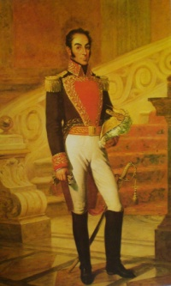
Movements for independence flourished in Latin America after the successes of the American and French Revolutions. The following leaders were integral to Latin America's struggle for independence:
Simon Bolivar (1783-1830) was one of South America’s most celebrated generals who helped win independence for Bolivia, Columbia, Ecuador, Peru and Venezuela. For his work promoting independence from colonial rule, Bolivar has been called the ‘Great Liberator’ and "the George Washington of South America." Between 1810 and 1824, Bolivar led a number of rebellions against the Spanish, culminating in him being named Dictator of Peru, a position which he used to continue to organize against colonial rule until his death in 1830. Bolivar continues to be central to the national narratives of the nations he helped to free.
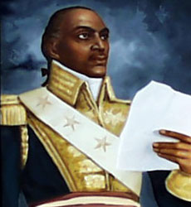
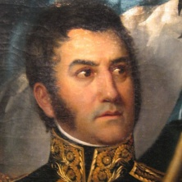
José de San Martin (1778-18) was an Argentine general who fought for the independence of Argentina, Chile and Peru from Spain. San Martin was educated in Spain and fought with the Spanish against Napoleon. In 1812, upon learning about the fight for independence in South America, San Martin sailed to Buenos Aires where he gained control of a small army. San Martin skillfully outmaneuvered the Spanish in Chile in 1818, and went on to help Peru win freedom in 1821. In 1822, he met with Simon Bolivar to discuss the future of Latin America, at which time the former ceded control of Peru to the latter.
Toussaint L'Ouverture (1743-1803) was the leader of the Haitian Revolution of 1794-1804.
- In 1789, the French Revolution inspired unrest in many of France's colonies, including Saint-Domingue, the French half of the island of Hispaniola.
- After the French Revolutionary government abolished slavery in 1794, L'Overture re-allied with the French and became brigadier general of a poly-racial army. In 1897, L'Ouverture became governor for life of Saint Domingue.
- In 1802, after gaining control of France, Napoleon Bonaparte attempted to regain control of and to restore slavery to the colony. Napoleon's troops captured L'Ouverture who died in prison in 1803.
- Revolutionary leaders Jean-Jacques Dessalines and Henri Christophe continued the fight for independence, and France surrendered at the end of 1803. On January 1st, 1804, Saint-Domingue became Haiti, the second independent nation in the western hemisphere (the first in Latin America) and the first free Black-led republic in the world.

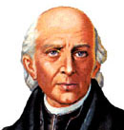
The Mexican Revolution
- Unhappy with Spanish economic policies and coupled with the successful revolutions in America and France, the Creoles pushed for reform and started the movement for independence.
- On September 16, 1810, Father Miguel Hidalgo demanded independence from Spain. He led a peasant uprising. He called for freedom for the lower classes in Spain. The conflict lasted 5 years but failed.
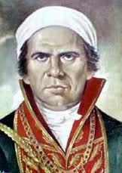
- In 1811, Father Jose Morelos, a mestizo, called for social and political reform, including: abolition of slavery, voting rights for all men. He led rebel forces, but was captured and killed in 1815.
- In 1820 the Creoles and Peninsulares joined forces, and on September 27, 1821, the Treaty of Cordoba Mexico wins its independence.
- In 1824 Mexico wrote a constitution, but over the next 40 years Mexico went through 56 different governments.
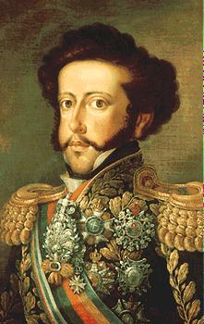
Brazil
- During the reign of Napoleon, the Portuguese royal family fled to Brazil. When they returned, the king’s son, Dom Pedro stayed behind to rule Brazil. After a revolution in 1822, Pedro became the emperor of an independent Brazil and established freedoms in the new constitution.

