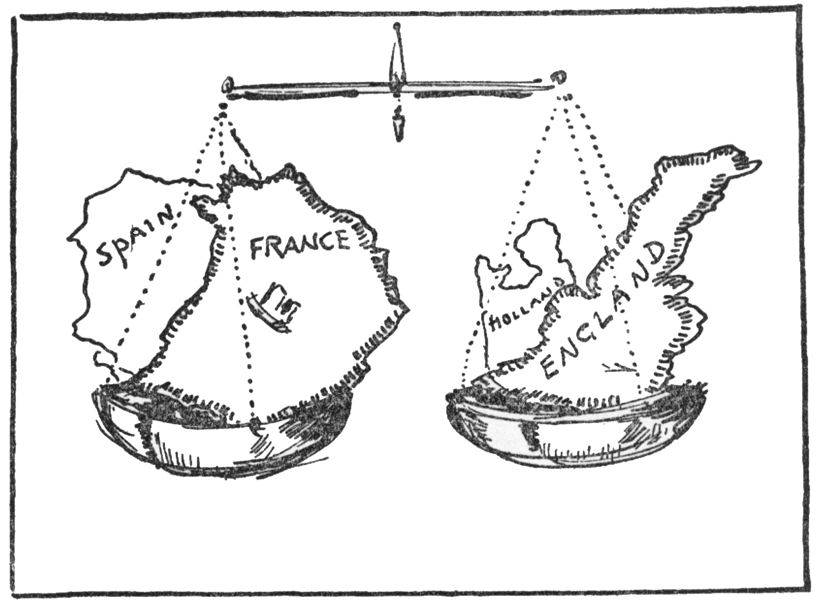
Nationalism Notes
Congress of Vienna
- After the downfall of Napoleon
- Met between
  - European leaders led by (Prime Minister )
- Goals
  - Prevent Aggression
  - Maintain (No country is a threat to anyone)
  - Restore families to the throne
- Result=5 Great Powers ( )
- Unintentional Side-Effect:
Before The Congress of Vienna After the Congress of Vienna
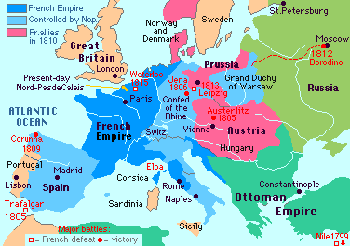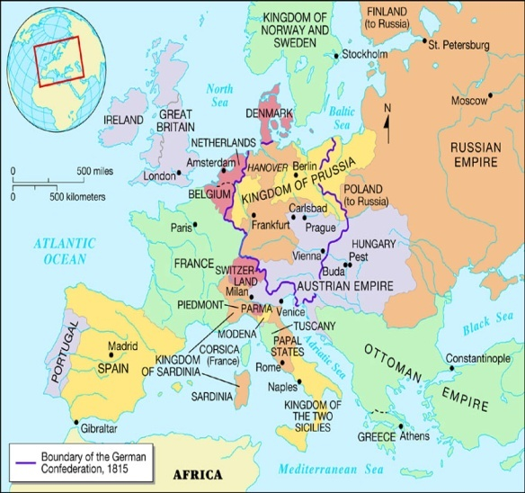
Nationalism
- Nationalism – belief that people should be loyal to not
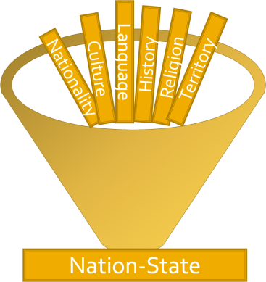
  - share a common
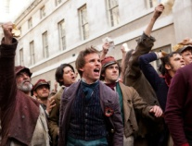
  - Can better with own
  - People have the right to
  - Nation-States—independent _____________, represents ___________________
    - Ex. England, France, Ireland, America
While watching the clip from Les Mis think about & record the following:
- What evidence do you see (or hear) of nationalism in France?

- What evidence do you see of class divisions?

- What are the complaints of the French people?

WHAT BELIEFS WERE HELD BY THE THREE FORCES FOR SUPREMACY?
Conservatives | Liberals | Radicals
- . & Nobility  - Argued for traditional _______________ | - ____________________  - Power to elected ____________________  - BUT only the ___________ and _________________ | - “_________” often _____________  - Extend democracy to _____________________  - _______________ changes

HOW DID NATIONISM PLAY A ROLE THE REBELLIONS AGAINST THE OLD ORDER?

1821 | 1830 | 1848
- ______________ (Muslims) control Balkan region  - ________ rebel  - Popular with scholars, Russians, many Europeans  - British, French, & Russians ally and crush Turks  - Greeks _____________ | - _______________ declare independence from ______  - _______ revolt against Russians, but are __________  - French king Charles X tries to _________________________________________________________________ ( it is put down) | - Summer of Revolutions: Berlin, Hungary, Czechs—______________to unite  - Paris mobs overthrow Louis-Philippe, ____________________  - Louis-Napoleon wins election; takes title of _____________________ ____________________  - Encourages __________  - Experiences ____________ ______________________

HOW DID NATIONALISM LEAD TO THE BREAKUP OF THESE EMPIRES?

Austro-Hungarian | Ottoman | Russian
Control Hungarians, Germans, Czechs, Slovaks, Croats, Poles, Serbs, & Italians | Turks control Greeks, Slavs, Arabs, Bulgarians, Armenians | Control Ukrainians, Poles, Lithuanians, Latvians, Estonians, Finns, Jews, Romanians, Georgians, Armenians, & Turks
- ___________ gains control of ______________ States  - Split ___________________ ______________________, but both under Emperor | - Grants equal _____________ to ________ people under rule  - Angers ______________ Turks—causes tension  - Ex: massacres of ___________ after a revolt (________________) | - Loses __________________ v. Ottomans  - Russification—impose ________________________  - Strengthened _____________ feelings of __________ groups  - ___________________ Russia  - ______________ czar’s power

HOW DID EACH OF THE FOLLOWING HELP UNIFY ITALY?
Giuseppe Mazzini  - Formed “__________ ________”—youth nationalist group  - 1848—Rebellions broke out, Mazzini briefly leads a ______________ in _______________  - Driven into __________ | Camillo di Cavour  - Prime Minister of Italian State _______________  - Expanded _____________ of Sardinia, ___________ most of _____________ Italy | Giuseppe Garibaldi and the Red Shirts  - Leader of nationalists rebels in ___________________ Italy  - Supported by _____________  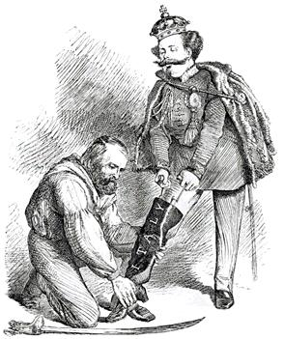  - Turned over control of Southern Italy to King ___________________ _________________ II of Sardinia  - United ______________ Italy

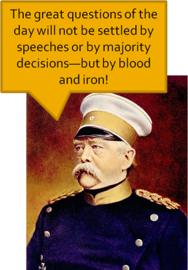
HOW DID EACH OF THE FOLLOWING LEAD TO GERMAN UNIFICATION?
Otto von Bismarck  - Prime minister of ______________ under Wilhelm I  - ________________—politics of reality  - practicality > idealism  - Encourages ______________ of Prussia through ______ | Austro-Prussian War  - Main obstacle is __________  - Prussia had ______________ training and equipment  - Austria __________________  - Territory turned over to Prussia, created ___________ ______________ Federation, led by Prussia | Franco-Prussian War  - __________ Germany unsure of Prussian control so…  - Bismarck ________ the ________ so they would _______________ on Prussia  - Prussians overwhelm ______ & capture ____________ III—force _______________  - Everyone is __________ to be German, so ___________ Germans accept __________ control  - King ________________ of Prussia is crowned ________ (emperor) of _____________

Summary: How did the Balance of Power in Europe shift due to Nationalist movements?
Answer this question by pondering: What happened to the Great 5 after the Congress of Vienna? Who has lost power? Who has power?

