BACKGROUND READING 1: The Slave Trade
Triangular Trade is a term used to describe the pattern of trade that emerged in the 1500s between the three lands bordering the Atlantic Ocean: Europe, Africa, and the Americas (Findlay 2). When Europeans began colonizing the Americas in the 1500s, they started plantations that grew cash crops like sugar, tobacco, and rice, which were then shipped back to Europe. Millions of human hands were needed to grow and harvest these cash crops. For that labor, Europeans turned to Africa (Postma 8-13). One leg of the triangular trade bears a particularly grim history. That leg was the transport of African slaves from Africa to the Americas, a journey called the Middle Passage. Africa had its own tradition of slavery when European sailors first began to explore its coast in the late 1400s. Africans traditionally enslaved war captives, some of whom were traded with Arabs (Walvin 52-53). As the need for labor in the European colonies of the Americas grew, Europeans encouraged the growth of African slave-catching by offering manufactured goods in exchange for slaves. African slave-catchers would kidnap villagers and bring them to slave trading fortresses along the coast. Here an African captive would be kept in a jail cell for days, weeks, or even months, until a slave purchaser arrived in his ship (Postma 21-22).
Question: What drove the European interest in slaves from Africa?

MORTALITY IN THE MIDDLE PASSAGE
Historians estimate that 12 million Africans were taken from their homes in Africa during the four centuries of the Trans-Atlantic Slave Trade. Of those put upon ships, about 10.5 million made it to land in the New World. Below are the slave mortality rates aboard 23 of the thousands of slave voyages.
MORTALITY CHART:
The mortality chart included contains a random selection of 23 voyages which flew the flags of different nations during the four centuries of the trans-Atlantic slave trade.
Date | Ship Name | Slaves boarded in Africa | Deaths | Mortality rate
1527 | Conception | 65 | 19 | 29%
1532 | S. Antonio | 201 | 26 | 13%
1592 | NS del Buen Viaje | 236 | 68 | 29%
1600 | NS del Roasario | 318 | 82 | 26%
1621 | S Buena Ventura | 236 | 68 | 29%
1637 | S Francisco Capuchino | 211 | 61 | 29%
1646 | Merchant of Barbados | 211 | 23 | 11%
1660 | New Westindisch Huis | 478 | 67 | 14%
1674 | Phenix | 516 | 46 | 9%
1691 | Armenian Merchant | 527 | 92 | 17%
1694 | Katherine | 600 | 114 | 19%
1712 | Comte de Lemoignan | 465 | 69 | 15%
1722 | Greyhound Sloop | 120 | 13 | 11%
1735 | St. Louis | 400 | 14 | 4%
1749 | Bom Jesus de Villanova e Almas | 634 | 84 | 13%
1750 | Prince de Conty | 601 | 58 | 10%
1759 | Upton | 251 | 46 | 18%
1767 | Nancy | 300 | 300 | 100%
1783 | Rusé | 169 | 19 | 11%
1800 | Margaret | 289 | 29 | 10%
1819 | Pastora de Lima | 435 | 37 | 9%
1820 | Boa Harmonia | 476 | 39 | 8%

Questions:
1.) How did the chart’s author determine the mortality rate of each voyage? (Wait, is this a math class?)
2.) What factors do you think might make a mortality rate higher or lower on a voyage?
3.) Why might the ship Nancy have had a mortality rate of 100%?
4.) What is the estimated overall mortality rate of the Middle Passage? (Yes, you have to do math here!)

BACKGROUND READING 2:
Once put into the hands of European slave traders, anywhere from 50 to almost 700 slaves were boarded onto wooden boats in shackles. They were taken under the main deck and chained together below the main deck on dismal shelves for storing the human cargo.
The spaces where the slaves were kept were pits of death. There was no light, no proper ventilation, and little or no sanitation. The smell of perspiration quickly blended with vomit, blood, urine, excrement, and dead bodies. The voyage on the slave ship could last anywhere from one month to five months. Many died from suffocation, but disease was responsible for about 70% of deaths (Postma 45). Outbreaks of dysentery, a disease caused by contaminated drinking water, were the main killers. Scurvy, a disease caused by a lack of vitamin C, also took many lives (Kolchin 21). Infectious diseases like smallpox and measles were also common (Postma 45).
When weather was good, slaves were taken above to the main deck and “danced” during the morning. Someone played a drum or another instrument, and the slaves were ordered to move about the ship for exercise (Kolchin 21). Here, they were also given their meals, which usually consisted or rations of beans, corn, rice, or yams. Sometimes, small amounts of meat would be added (Postma 24). If the weather was not good, however, slaves were kept in the slimy under-decks all day and all night (Postma 27).
Depression and desperation caused many slaves to lose the will to live. Some committed suicide by finding opportunities to throw themselves overboard or refusing food (Postma 45). Crew members tried to prevent self-starving through torturous force-feeding (Kolchin 21) The goal of the slavers after all, was to get as many slaves as possible to ports in the New World (Walvin 65).
Economic concerns sometimes led to throwing live slaves overboard. If any slaves showed signs of smallpox, a disease which could wipe out large portions of the slaves and the crew, they would be thrown overboard. Signs of opthamalia, a disease which caused temporary blindness, threatened the value of the slaves, and any slave showing signs of this disease was also thrown overboard. Sometimes, if the voyage was taking too long and rations were running too thin, the sickest slaves would be thrown overboard so that the healthier ones would have the rations to make it to port (Walvin 67). Sometimes, slaves aboard a ship would revolt. Revolts would sometimes result in the death of slaves. Slaves who seemed rebellious would be flogged, or beaten.
Finally, some ships sank, taking down their entire crew and kidnapped cargo.
Questions:
1.) Describe the conditions on the decks where the slaves were kept.
2.) What were the causes of slave deaths aboard the slave ships? List at least 6 causes of death.
3.) Do you think the crews on slave ships wanted to hurt the slaves? Why or why not? List at least 3 things that would prompt the crew to kill a slave.

VINGETTES: Primary Sources on the Middle Passage
“Space on the slave decks” by Alexander Falconbridge. Falconbridge was an English surgeon aboard a slave ship. He recorded some of what he witnessed.
“…they are frequently stowed so close, as to admit of no other position than lying on their sides. Nor will the height between decks…permit the indulgence of an erect posture; especially where there are platforms, which is generally the case. These platforms are a kind of shelf, about eight or nine feet in breadth, extending from the side of the ship toward the centre. They are placed nearly midway between the decks, at the distance of two or three feet from each deck, Upon these the Negroes are stowed in the same manner as they are on the deck underneath….”
Questions:
1.) Why did the slaves have to lie only on their sides?
2.) Why were European slavers packing the slaves so tightly together?
Food
“…The diet of the Negroes while on board, consists chiefly of horse beans boiled to the consistency of a pulp; of boiled yams and rice and sometimes a small quantity of beef or pork. The latter are frequently taken from the provisions laid in for the sailors. They sometimes make use of a sauce composed of palm-oil mixed with flour, water and pepper, which the sailors call slabber-sauce. Yams are the favorite food of the Eboe or Bight Negroes, and rice or corn of those from the Gold or Windward Coast; each preferring the produce of their native soil....Upon the Negroes refusing to take sustenance, I have seen coals of fire, glowing hot, put on a shovel and placed so near their lips as to scorch and burn them. And this has been accompanied with threats of forcing them to swallow the coals if they any longer persisted in refusing to eat. These means have generally had the desired effect. I have also been credibly informed that a certain captain in the slave-trade, poured melted lead on such of his Negroes as obstinately refused their food....”
1.) What would happen to slaves who refused to eat?
2.) Why do you think they tortured slaves who did not want to eat?

“Space on the slave decks” by Alexander Falconbridge. Falconbridge was an English surgeon aboard a slave ship. He recorded some of what he witnessed.
Ventilation of the ships
“...The hardships and inconveniences suffered by the Negroes during the passage are scarcely to be enumerated or conceived. They are far more violently affected by seasickness than Europeans. It frequently terminates in death, especially among the women. But the exclusion of fresh air is among the most intolerable. For the purpose of admitting this needful refreshment, most of the ships in the slave trade are provided, between the decks, with five or six air-ports on each side of the ship, of about five inches in length and four in breadth….But whenever the sea is rough and the rain heavy, it becomes necessary to shut these and every other conveyance by which the air is admitted. The fresh air being thus excluded, the Negroes' rooms soon grow intolerable hot. The confined air, rendered noxious by the effluvia [gases] exhaled from their bodies and being repeatedly breathed, soon produces fevers and fluxes [dysentery] which generally carries off great numbers of them. During the voyages I made, I was frequently witness to the fatal effects of this exclusion of fresh air. I will give one instance, as it serves to convey some idea, though a very faint one, of their terrible sufferings....Some wet and blowing weather having occasioned the port-holes to be shut and the grating to be covered, fluxes and fevers among the Negroes ensued. While they were in this situation, I frequently went down among them till at length their room became so extremely hot as to be only bearable for a very short time. But the excessive heat was not the only thing that rendered their situation intolerable. The deck, that is the floor of their rooms, was so covered with the blood and mucus which had proceeded from them in consequence of the flux, that it resembled a slaughter-house. It is not in the power of the human imagination to picture a situation more dreadful or disgusting. Numbers of the slaves having fainted, they were carried upon deck where several of them died and the rest with great difficulty were restored. It had nearly proved fatal to me also. The climate was too warm to admit the wearing of any clothing but a shirt and that I had pulled off before I went down.... In a quarter of an hour I was so overcome with the heat, stench and foul air that I nearly fainted, and it was only with assistance I could get back on deck. The consequence was that I soon after fell sick of the same disorder from which I did not recover for several months....” Questions
1.) How did Alexander Falconbridge attribute poor weather to an increase in disease?
2.) Why did the interior of the slave ship look like “a slaughter-house?”

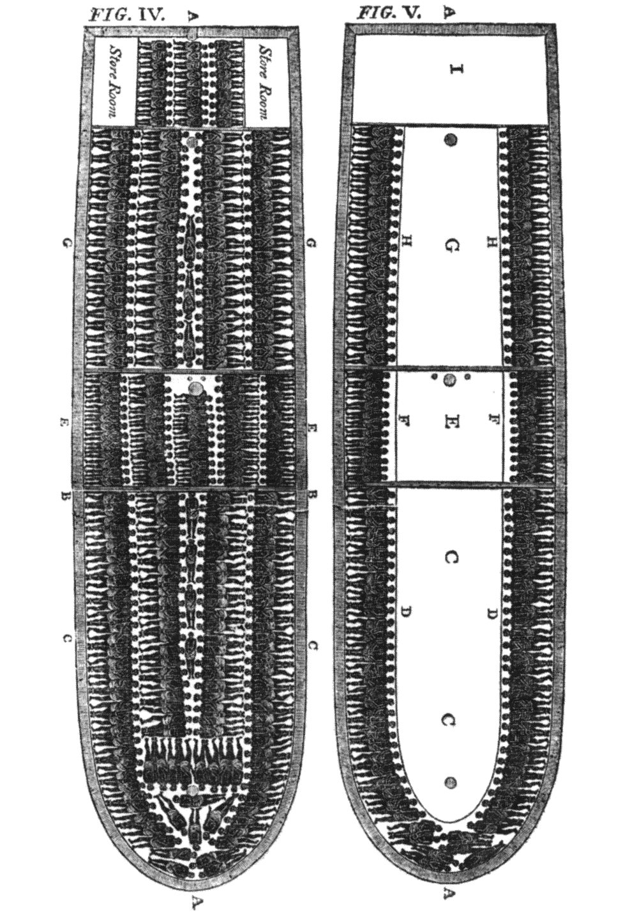
Picture: A detailed drawing of the slave ship Brookes. 482 people were to be packed onto the decks. This dates from 1789.
–Source: Library of Congress

1.) What details from this picture stand out the most?

“Jumping Overboard” – Olaudah Equiano
Olaudah Equiano was an African who was transported taken from Africa and enslaved in the New World
“Soon after this the blacks who brought me onboard went off, and left me abandoned to despair. I now saw myself deprived of all chance of returning to my native country, or even the least glimpse of hope of gaining the shore, which I now considered as friendly; and I even wished for my former slavery in preference to my present situation, which was filled with horrors of every kind, still heightened by my ignorance of what I was to undergo. I was not long suffered to indulge my grief; I was soon put down under the decks, and there I received such a salutation in my nostrils as I had never experienced in my life: so that, with the loathsomeness of the stench, and crying together, I became so sick and low that I was not able to eat, nor had I the least desire to taste anything. I now wished for the last friend, death, to relieve me; but soon, to my grief, two of the white men offered me eatables; and, on my refusing to eat, one of them held me fast by the hands, and laid me across I think the windlass, and tied my feet, while the other flogged me severely. I had never experienced any thing of this kind before; and although, not being used to the water, I naturally feared that element the first time I saw it, yet nevertheless, could I have got over the nettings, I would have jumped over the side, but I could not; and, besides, the crew used to watch us very closely who were not chained down to the decks, lest we should leap into the water: and I have seen some of these poor African prisoners most severely cut for attempting to do so, and hourly whipped for not eating. This indeed was often the case with myself…
One day, when we had a smooth sea and moderate wind, two of my wearied countrymen who were chained together (I was near them at the time), preferring death to such a life of misery, somehow made through the nettings and jumped into the sea: immediately another quite dejected fellow, who on account of his illness was suffered to be out of irons, also followed their example; and I believe many more would very soon have done the same if they had not been prevented by the ship's crew, who were instantly alarmed. Those of us that were the most active were in a moment put down under the deck, and there was such a noise and confusion amongst the people of the ship as I never heard before, to stop her and get the boat out to go after the slaves. However two of the wretches were drowned, but they got the other and afterwards flogged him unmercifully for thus attempting to prefer death to slavery.”
Questions
1) What did the sailors do to Equiano when he refused to eat and the slave they rescued from drowning? Why do you think they did that?

Middle Passage Document Walk Note Taking Sheet
In the chart below, answer the questions for each document. You should also take any addition notes of connections between the documents or things that stand out to you.
Background Reading 1

Mortality Chart

Background Reading 2

Vignette: Space on the slave decks & food

“Ventilation of the Ships”

Picture: Drawing of the Slave Ship Brookes

“Jumping Overboard”

