**MEDIEVAL CHURCH**

**THE CHURCH IN MEDIEVAL LIFE**

* During the Middle Ages, two distinct Christian churches emerged: the Orthodox Christian Church in the east and the Roman Catholic Church in the west. (The two branches split permanently in 1054.)
* The Roman Catholic Church became the main stabilizing force in Western Europe. The church provided religious leadership as well as secular, or worldly, leadership. It also played a key role in reviving and preserving learning.
* At the head of the Roman Catholic Church was the pope, whom followers believed to be the spiritual representative of Jesus on earth. Below the pope came cardinals, archbishops, bishops, and local priests. For peasants and town dwellers, everyday life was closely tied to local priests and the village church.
* The main responsibility of the church was to serve the spiritual needs of medieval society. Local priests instructed peasants and townspeople in the faith and provided comfort to them in troubled times.
* The Church taught that all men and women were sinners but that Christians could achieve salvation, or eternal life in heaven, through faith in Jesus, good works, and participation in sacraments, or sacred spiritual rituals. To escape the punishment of hell, they needed to take part in the sacraments of the Church.

**SECULAR ROLE OF THE CHURCH**

* The Church filled many secular (non-religious) roles during the Middle Ages. As the largest landholder in Europe, the Church had significant economic power. The Church also gained wealth through the tithe, a tax Christians were required to pay that equaled ten percent of their income.
* The Church had their own set of laws called canon law, and its own courts of justice. The Church claimed authority over secular rulers, but monarchs did not always recognize this authority. As a result, there were frequent power struggles between the pope in Rome and various kings and emperors.
* Popes believed that they had the authority over kings. Popes sometimes excommunicated or excluded from the Catholic Church, secular rulers who challenged or threatened papal power. For example, Pope Innocent III excommunicated King John of England in the 1200s during a dispute about appointing an archbishop.

Pope Innocent III

**MONASTIC LIFE**

* Some men and women became monks and nuns, leaving worldly society and devoting their lives to God. They entered **monasteries,** communities where Christian men or women focused on spiritual goals.
* Monks and nuns took vows of chastity, or purity, and of obedience to the abbot, or head of the religious order. They also took an oath of poverty.
* Monks and nuns also filled many other social needs, such as tending to the sick, helping the poor, and educating children.
* 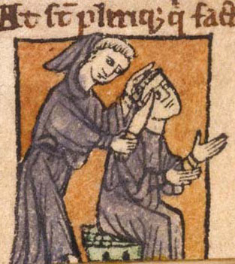In monasteries and convents (religious communities of women) monks and nuns also preserved ancient writings by copying ancient texts. Some monks and nuns taught Latin and Greek classics; others produced their own literary works.
* Wandering friars traveled from place to place preaching and spreading the Church’s ideas. Like monks, friars took vows of chastity, poverty, and obedience. Unlike monks, friars did not live apart from the world in monasteries. Instead, they preached to the poor throughout Europe’s towns and cities. Friars owned nothing and lived by begging. St. Francis of Assisi and St. Dominic of Spain founded the first two orders of friars.
* Not all monks and nuns remained in monasteries. Some became missionaries, risking their lives to spread the message of Christianity. The Church sometimes honored its missionaries by declaring them saints. St. Patrick was a missionary who set up the Church in Ireland. St. Augustine was sent as a missionary to the Angles and Saxons in England.

**WOMEN IN THE CHURCH**

* The Church taught that women were equal in the sight of God. However, on earth, women were supposed to be subservient to men.
* Parents would often put daughters in convents if they could not afford to keep them and/or find them a husband.
* 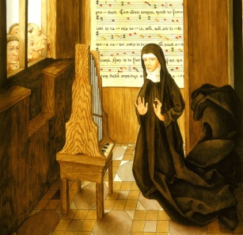Women joined the Dominicans, Benedictines, and Franciscans. In 1212, a woman named Clare and Francis of Assisi founded the Franciscan order for women. It was known as the Poor Clares.
* In Germany, Hildegard of Bingen, a mystic and musician, founded a Benedictine convent in 1147.
* Like friars, these women lived in poverty and worked to help the poor and sick. Unlike the friars, however, women were not allowed to travel from place to place as preachers.
* There was some effort to protect women in medieval society. For example, the Church set a minimum age for women to marry. However, women were viewed in two opposing way. On one hand, the Church considered women weak, easily tempted into sin, and dependent on the guidance of men. On the other hand, women were seen as modest and pure in spirit, similar to Mary, the mother of Jesus.

**JEWS IN MEDIEVAL EUROPE**

* Numerous Jewish communities existed throughout Europe during the Middle Ages.
* While Jews in Muslin Spain and northern areas of Europe were generally tolerated, most Christians persecuted Jews. The Church barred Jews from owning land or practicing many occupations. Many Christians also blamed Jews for the death of Jesus.
* As a result, the foundations for **anti-Semitism,** or prejudice against Jews, were laid. Gradually Christians began blaming Jews for all kinds of misfortune including famines and diseases. This is called a **scapegoat.**
* In time, Jews migrated to Eastern Europe where they set up communities that survived until modern times.
* Anti-Jewish painting:

In the box below, write a summary paragraph of the information above, describing the Medieval Church.