Name: ________________________________________________ Period: ________ Date: ___________
Map of the World
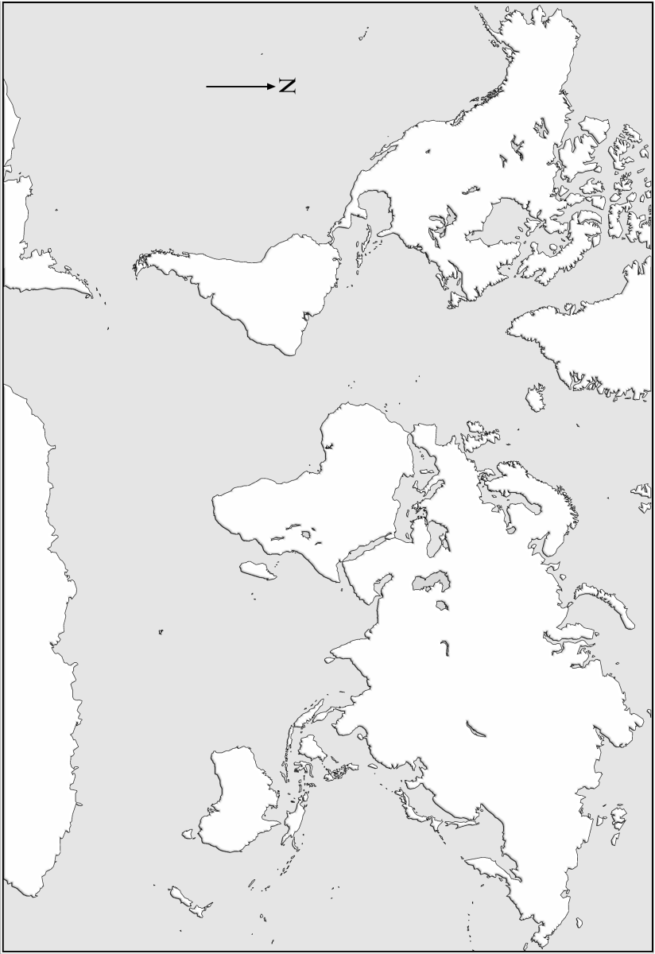
Map of Europe
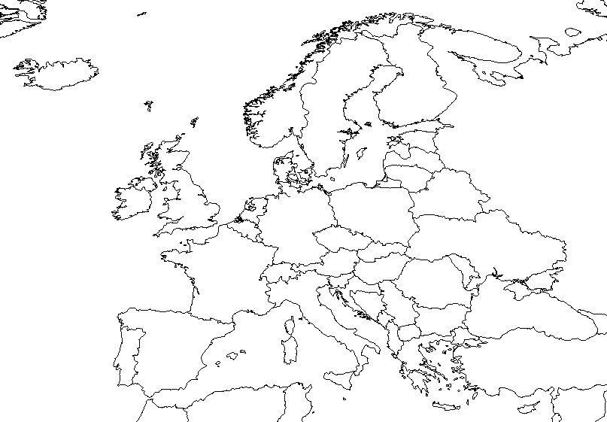
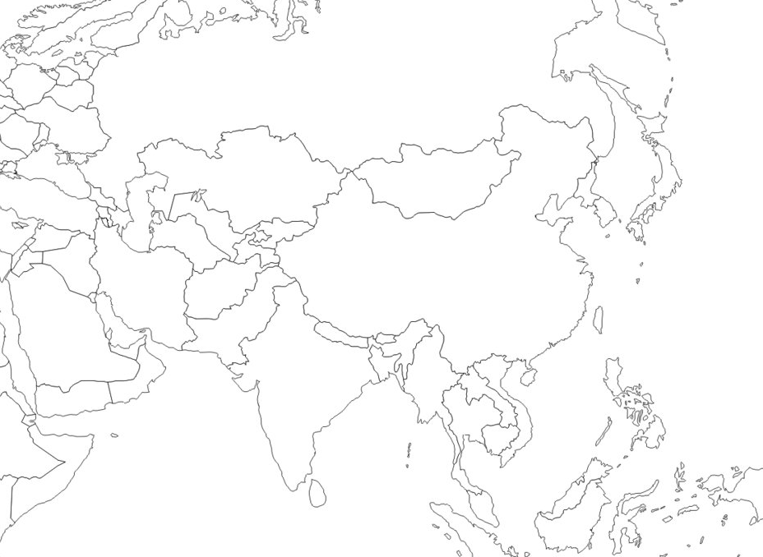
Map of Asia
Map of the World
1. In the upper left corner of your map draw a compass rose.

2. Use a ruler to draw a dashed (--------) line and correctly label:
Equator Tropic of Capricorn
Meridian of Greenwich (Prime Meridian) Tropic of Cancer

3. Label each of the following bodies of water:
Atlantic Ocean Pacific Ocean
Indian Ocean Mediterranean Sea

4. Label each of the following continents and/or areas of land.

Africa
Antarctica
Asia
Australia
Europe
North America
South America
Arabian Peninsula
Indonesia

5. Label the following geographical features:
Himalayan Mountains Sahara Desert The Andes Mountains

Map of Europe
1. In the upper left corner of your map draw a compass rose.

2. Label each of the following bodies of water:

Atlantic Ocean
Baltic Sea
Black Sea
Mediterranean Sea
Rhine River
North Sea

4. Label and underline each of the following mountain ranges
The Alps The Urals The Pyrenees

3. Label each of the following countries:

GREAT BRITAIN
FRANCE
SPAIN
GERMANY
RUSSIA
ITALY
BALKAN PENINSULA
POLAND
NETHERLANDS
NORWAY
SWEEDEN
FINLAND

Map of Asia
1. Label each of the following bodies of water:
Persian Gulf Indian Ocean Pacific Ocean

2. Label each of the following countries:

IRAQ
IRAN
INDIA
CHINA
KOREA
JAPAN

