Name Class Date
24.1: Latin American Independence
By the late 1700s, the spirit of Revolution had spilled over from Europe to Latin America.
Answer the following questions about the causes for these revolutions and then use the map on the opposite side to chart them.

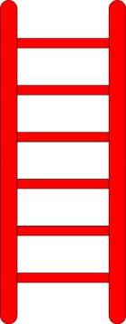
- On the ladder below, rank the Latin American social classes from highest to lowest. Describe who they were and the rights they had.

- Look at the graph on page 604. Which two social groups make up the largest percentage of the population in Latin America? ________________________________________________
- Which social group primarily read the works of Enlightenment writers? ______________

- Who invaded Spain and what effect did it have on Latin American leaders? ___________

________________________________________________________________________
Map
On the map, chart the revolutions of the following countries by locating them, labeling who led the rebellion, and what year that country gained independence. Use reading and maps in 24.1 and the atlas of your text book to help you.
- Haiti
- Venezuela, Colombia, Ecuador, Panama (Gran Colombia/Spanish South America)
- Mexico
- United Provinces of Central America
- Brazil
