**C:\Documents and Settings\rjones9\Local Settings\Temporary Internet Files\Content.IE5\KMHYTNJY\MC900047995[1].wmfFoundational Concepts in Hinduism**

**Samsara**: cycle/wheel of life, death, rebirth that is the basic state of existence   
Time is cyclical, not linear- cycles of creation and destruction in the universe- reincarnation for the universe over vast periods of time

**Reincarnation**- series of lifetimes needed to achieve the goal of liberation/release from this world (samsara- ‘wheel of rebirth’) divine spark (atman) is reborn, usually cannot remember past lives  
Reborn as: people, animals, gods and goddesses in many heavens, demons in many hells other steps in between- even gods are reincarnated

**Moksha**= liberation or release, characterized by union with the divine, awareness, bliss- a mystical state of being that cannot be explained- returned to the sacred source- ends the cycle of reincarnation

**Brahman**= The shared divine essence of all things, beyond the reach of human perceptions- we see distinctions and separations, not the unity of Brahman- we need knowledge and discipline to see the truth

**Atman**= the ultimate reality within, the Brahman inside, understood through contemplation of the self, “soul”

**Polytheistic**= 330 million gods, all faces of the one, points of contact with the divine

Three most important gods:

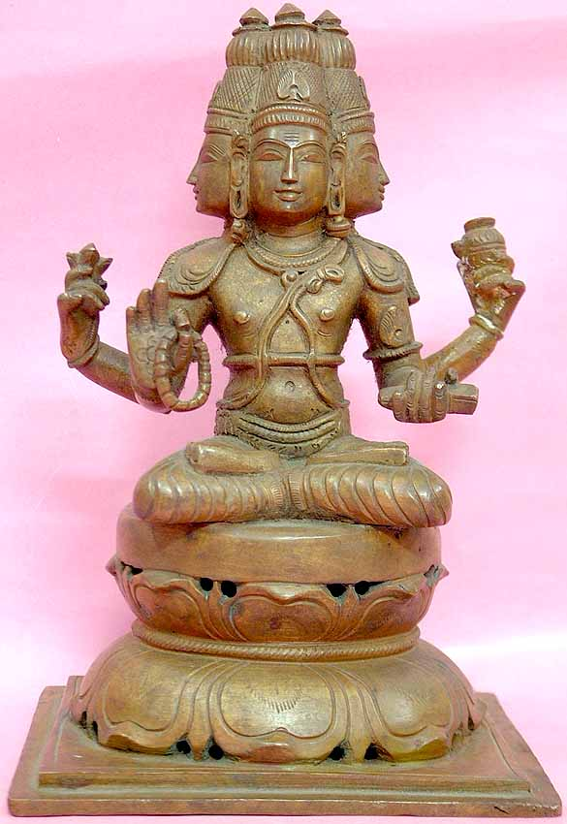 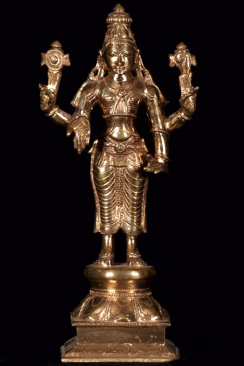 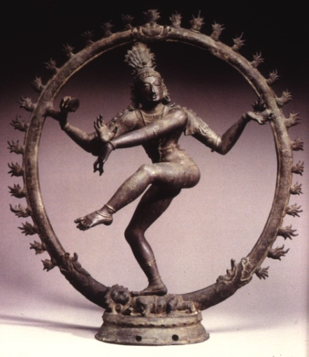

Brahma: The Creator Vishu: The Preserver Shiva: The Destroyer

**Karma**= actions, deeds- moral law of cause and effect as you sow so shall you reap- deeds provide positive or negative merit

* Determines your next reincarnation as good or bad, close or far to realizing samsara
* Only humans can change their karma by doing deeds that produce merit
* Bad things happen to good people because those good people were bad in a past life

**Dharma**= ethical duty based on divine order of reality- the standards on which to judge karma- the deeds that create merit

* Complete rule of life, not just right vs wrong, but compassion or golden rule
* Determined by gender, caste, stage of life
* Supports caste system- you are in a lower class because you did not follow your dharma and accumulated bad karma

**Goals of Life:**

1. Dharma- following dharma, you ethical duty, because you truly want to not just because you are supposed to- better to give than to receive- very good, yet still in the world, still bound by samsara
2. Moksha- liberation, bliss, unity with the great ocean of brahman