The Byzantines: Engineering an Empire

1. The Byzantines called themselves “Romanos” or those who continued the of the Empire.
2. The Byzantine Empire was the dominant force in the .
3. November 8, 324 AD, after two decades of bloody civil war, the emperor finally seized sole control of the entire Roman Empire.
4. What did Constantine achieve? (list several)
5. What is the name of Constantine’s city today, population 12 million?
6. How long were the great aqueducts that were built to supply water to Constantine’s city?
7. What modern day country does Istanbul lie in today?
8. 410 AD, Rome has fallen to called Visigoths. Romans fled eastward to the safe haven of Constantinople. Who was the threat in the east?
9. Describe the walls built to keep out the Huns:
10. Attila got some help from Mother Nature in his attempt to take Constantinople. What happened?
11. **True or False:** The Huns never breached (broke through) the city walls.
12. Constantinople was the city in the world.
13. Throughout the 5th century, the Roman Empire had been steadily disintegrating under the iron fist of barbaric tribes. In 476, the last Roman emperor the throne. To many, the Roman Empire had finally .
14. 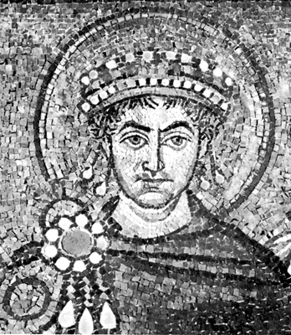Justinian I ruled during the Byzantine Empire’s golden age. He was born a peasant. He married . He promoted her to . Together they would rule the empire as .
15. **True or False:** Justinian was wildly popular.
16. Describe the Hippodrome:
17. After the riot, why didn’t Justinian pack his bags and leave?
18. How many rebels are killed in the Hippodrome?
19. C:\Documents and Settings\rjones9\Local Settings\Temporary Internet Files\Content.IE5\KMHYTNJY\MC900188475[1].wmfJustinian leaves us with a great architectural legacy: he rebuilt the city’s main cathedral called the . Today we call it the Hagia Sophia.
20. Describe the Hagia Sophia:
21. By the end of Justinian’s reign, how big was the empire?
22. **True or False:** After Justinian, the economy and the people of Byzantium are better off than they were before.
23. The man at the helm of the Byzantine’s comeback is . A man of the people, Basil II was the most brilliant military mind the Byzantines would ever produce.
24. What did Basil do to Samuel’s army?
25. In AD, when Basil died, the Byzantines were at the pinnacle of their power, but the empire was left rudderless and vulnerable to .
26. What did the Ottomans use against the Byzantine walls? Were they successful?

**After 1100 years the walls were finally breached by the Ottomans. Constantinople was now Istanbul. The Byzantine Empire had ended, but its innovation and engineering feats stand today as a testament to the magnificent civilization, one that borrowed from Rome’s chapter in the book of great empires and then added its own.**