C:\Users\Rebecca\AppData\Local\Microsoft\Windows\Temporary Internet Files\Content.IE5\HK0KO96M\MC900352298[1].wmf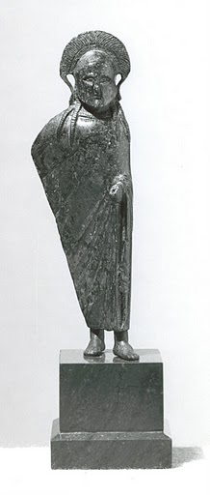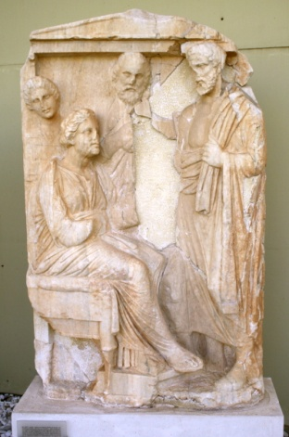

Population and Geography

**Athens:** Approximately 140,000; *They were influenced by the same geographical features—the water that surrounded them facilitated trade and travel. In addition, their strategic location facilitated trade with other regional powers.*  
  
**Sparta:** Approximately 100,000; *While Sparta had a similar geographic location as Athens, Sparta did not use its location to facilitate trade and travel. While Sparta and Athens are not that far from each other, there landscapes differ greatly.**Instead, Sparta turned inward cutting itself away from the influences of other regional powers*

* Besides the obvious differences in philosophies, there is a very big difference in geography that caused these differences. Ancient Athens was situated somewhat close to the coast; it was only about five miles to the port city of Piraeus (which became part of Athens with the building of the Long Walls), thus it was no more than a few hours of travel from Athens to the coast line, thus greatly increasing the ability to be a trade center. Ancient Sparta however is located at the shortest distance 40 miles from the coast, however the terrain is somewhat rocky and there is no real straight path to the coast line and greatly hurt the ability for Sparta to become a major trading port

Government & Political Organizations

**Athens** **Government:** *Typically classified as a “limited democracy.” Also considered the “birthplace of democracy*.”

* Athens held the first democratic state, developed in 507 BC.
* Principally made up of elected officials:
  + Council of 500 made most of the main administrative decisions
  + The Assembly was open to all citizens. This body passed laws and made policy decisions.
* Although many nations throughout time have modeled their governments on the principles of Athenian Democracy, it was not perfect. Only men were able to participate in the democratic assemblies, and this was only 10-20% of the population. Women, children, slaves and foreigners were not allowed to participate.

**Spartan Government:** *Typically classified as an "oligarchy" (rule by the few), but had elements of monarchy, democracy, and aristocracy*

* Two kings were usually generals who commanded the major Spartan armies. While both were capable military leaders one was usually considered the leader of the army. This was done mainly so that in times of war Sparta would still retain a leader if the other were to die in battle. The most famous example was King Leonidas, who famously was able to hold off the enormous Persian Army at the battle of Thermoplyae.
* Five overseers (ephors) ran the day-to-day operations of Sparta. These overseers held one year terms and were responsible for the education and conduct of all its citizens (The Essential World History, W. Duiker & J. Spielvogel, Second Edition, 2005, p. 76)
* Council or Senate (apella) of 28 councilmen. These men had to be over 60 years old and served lifetime terms. They acted as judges and proposed laws to the citizens' assembly.
* All Spartan males over age 30 could join the Assembly where they could show their support/dissent by shouting.

Social Structure

**Athens Social Structure**

* Freemen constituted all male citizens, divided into numerous classes:
  1. At the top, the aristocrats held large estates and made up the cavalry or captain triremes.
  2. Middle ranks consisted mostly of small farmers.
  3. The lowest class was the thetes who were usually urban craftsmen or rowers.
* Metics – the people who lived outside the walls of Athens
  + Unable to own land
  + Could run industries and businesses
* Slaves constituted the lowest class in Ancient Athens. Slaves had no rights. They constituted one fourth of the population. Though they often held important positions such as teachers and nurses.
* Women’s principal role in Ancient Athens was in the home. They held no rights in the Athenian democracy.

**Spartan Social Structure**  
Society was broken up into three main classes:

1. Spartiates – the military leadership who ruled the barracks. These men served in the military and could also vote.
2. Perioeci - the freemen in Ancient Sparta. These included: artisans, craftsmen, and merchants. While they did serve in the army, members of this group could not vote.
3. Helots – were serfs who generally descended from people overtaken by Spartan military victories. In addition to the conquest of land, these helots were the fruits of war. Members of this group typically gave half of their profits to the Spartan citizens who owned the land.

*Female_Rose.pngIn comparison with Ancient Athens, Spartan women held a variety of rights*. *For example, women could own property and engage in athletic events like the men in Ancient Sparta.*

**WHY SPARTAN WOMEN WERE MORE DOMINANT IN SOCIETY THAN THEIR ATHENIAN SISTERS**

1. Girls were given a good education in both the arts and athletics.
2. Women were encouraged to develop their intellect.
3. Women owned more than a third of the land.
4. There was less difference in age between husbands and wives, and girls in Sparta married at a later age than their sisters in Athens.
5. Husbands spent most of their time with other men in the military barracks; since the men were rarely home, the women were free to take charge of almost everything outside of the army.
6. Mothers reared their sons until age 7 and then society took over. Fathers played little or no role in child care.

Language and Religion

**Athens:**  
Same language, religion and gods as the Spartans. According to Duiker & J. Spielvogel, “religion was a civic duty necessary for the well-being of the state.” (pg. 81)

* Polytheistic
* Zeus was the supreme leader
* Patron (main) goddess of the city: Athena (goddess of wisdom)

**Sparta:**  
Same language, religion and gods as the Athenians.

* Polytheistic
* Zeus was the supreme leader
* Patron gods: Ares (god of war) and Artemis (goddess of the hunt)

Military Strength and Cultural Values

**Athens:**  
*Strong navy and fortification*  
*Strong belief in the democratic process*  
  
**Sparta:**  
*Strong army - overwhelmed opponents in sheer military strength*  
*Strong belief in militaristic values. Their society was built upon a structure of order and discipline.*

Education

**Athens:**  
*Boys: Learned an array of subjects including reading, writing, mathematics, music, poetry, sports and gymnastics.*

*Girls: Females received scant* *formal education. Instead, these women would focus on domestic skills like weaving and spinning.*  
  
**Sparta:**  
*Boys: Formal educations in the schoolhouses were not prized in Ancient Sparta. At the age of 7, boys would be placed into state-run training centers. At 20, Spartan males entered military services where they needed to serve until age 60 (essentially their entire lives!). Spartan men could marry at the age of 20, however they were unable to live with their families until age 30 when they left active military service.*

*Girls: On the other hand, females did receive some lessons in reading and writing. In addition, they could participate in sports.*

Life and Arts

**Athens:**

* *Much of what we have come to think of as the ingenuity and innovations of ancient Greece came from Athens. It was the largest and most culturally influential city-state, and the people were known for their love of learning and the arts, as well as great leaps forward in philosophy and science.*
* *Aside from being great writers and scholars, the Athenians were great architects. One of their most famous buildings, the Pantheon, is still an architectural marvel nearly 2500 years after its inception.*

**Sparta:**

* *Spartans did not place a high value on the arts, education or architecture.*
* *Spartans did not trade with others because they didn’t want to be influenced by any outside cultures.*
* *According to Duiker & Spielvogel, Spartan citizens were discouraged to study the ideas of literature, science, and philosophy fearing that these new ideas could endanger the stability of the state (pg. 74)*

Cultural Achievements and Legacy

**Athens:**  
*Left a large contribution to modern society. The arts, architecture, drama, literature, philosophy, science, medicine and government (democracy, trial by jury) are all ideas and disciplines that had great influence in Ancient Athens.*  
  
**Sparta:**  
*Military prowess.*  
  
This is best evidenced by the fact in the difference of the modern appearance of the two cities. Athens, which is also the capital of modern Greece, is a vibrant tourist community with great ties to its past. They still have numerous ancient buildings at least partially standing and have numerous museums dedicated to artifacts from the past. However when you go to Sparta, the only thing letting you know that it is actually the location of one of the greatest military powers of the ancient world, besides the signs obviously, is the giant statue of King Leonidas outside of a recreational facility.

C:\Users\Rebecca\AppData\Local\Microsoft\Windows\Temporary Internet Files\Content.IE5\HK0KO96M\MC900352298[1].wmf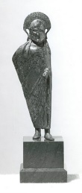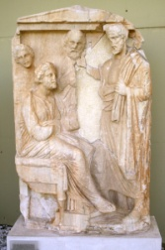Questions: City-State Dual Ancient Athens vs. Ancient Sparta

1. Which city-state would you rather live in if you were: (Be sure to tell **WHY**.)

* a young teenage girl?
* a slave?
* a young boy?
* a very wealthy person of the citizen class?
* a merchant?
* a solider?

1. Which city-state was most known for cultural achievements (art, music, literature, etc)?
2. Which city-state is most known for warfare?
3. What do the patron gods of each city-state say about what’s important to them?
4. Which city-state’s government do you think is the best, and why?

Now, choose either Athens or Sparta and create an advertisement to try and convince people to visit that city. Include at least 2 reasons why the one you choose was best.