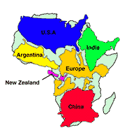
Africa Notes
Africa’s Size
- largest continent
- of the world’s population

Continent of Africa
- Very environments
- Dessert & rainforests
- Insect diseases:
- Most people live in
Emergence of Civilization
- The Land
  - is the great divide
- Nomadic—herders
  - Migration: peoples
    - Farming and ironworking
- Family=

- : religion/ancestor worship
- : specialized storytellers, pass and preserve history

Bantu Migration
- Bantu migration spread use of across continent
- Where did Bantu language come from (video clip)?

- What did we learn from Mapungubwe —Place of the Jackal (video clip)?

North Africa: Axum
- Rich state
- Followed Christianity
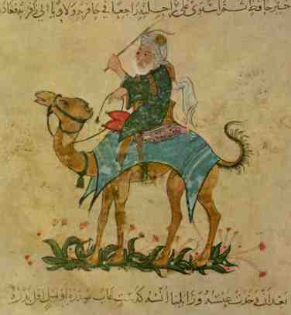
  - Mixes Christian and African
- Now
States of West Africa
- Expansion of Islam
  - becomes main language
- Ghana
  - Trade
  - Very : “Land of “
  - Kings convert to , BUT the did
- Mali
  - Wealth from trade
    - Eventually conquer
  - Mansa Musa, encouraged , built in
- Songhai
  - builds vast military state: expands empire
  - Ruled years
  - Lacked modern : in 1591 to
East Africa
- Self-governing
  - with the interior, Indian Ocean, China, and along the coast
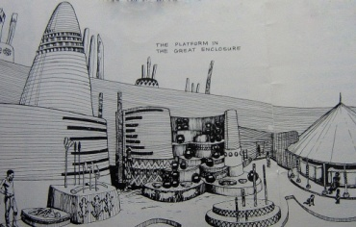
  - Influenced by
  - Ex:
  - Often traded
- Mixed culture
  - Mixed culture and language called
Stateless Societies of South Africa
- From the basin of the to the
- Stateless society: power is not in a
- Progress made with
- Zimbabwe (Sacred House, )
  - Capital known as
  - Benefited from trade between
  - Evidence of , but Great Zimbabwe

Crash Course #16: Mansa Musa and Islam in Africa
Question |  | Choice 1 | Choice 2 | Choice 3
 | Much of African History was preserved by ___ tradition | Written | Oral | Google
 | In 1314, Mansa Musa left Mali to make the pilgrimage to | Medina | Jerusalem | Mecca
 | When he reached Alexandria, he spent so much he caused | Inflation | Wealth | Deflation
 | Mansa Musa undermines the stereotype that Africans were | Wealthy | Poor | Middle Class
 | Pastoral North Africans called Berbers traded… | Pepper | Silver | Salt
 | …In exchange for | Gold | Pepper | Wool
 | When Mansa Musa returned from his hajj he brought back | Wealth | Scholars | Christianity
 | Traveler and historian who wrote about Mali | Sonja Ali | Mansa Musa | Ibn Battuta
 | The Eastern Coast saw the rise of __ | Swahili | Bantu | Axumite
 | The Bantu brought (circle two) | Iron-Work | Herding | Agriculture
 | In the East, agriculture took hold, which it does unless you are | Mongols | Mongols | Mongols
 | For a long time historians believed East African was started by | Arab | Greek | Roman
 | Which was | Racist | Racist | Racist
 | Most of the goods exported were | Raw materials | Manufactured | Luxury Goods
 | Studying Africa reminds us to look at lots different kinds of | Sources | Documents | Artifacts

