World History Final Project

You will need to discover the main concepts and important events and/or people for the historical eras listed. This does not mean small details, but **big picture** (for example, you do not need to know the dates of the Reign of Terror in France, but why it happened.)

After you complete your research, you will need to create museum exhibits that emphasize these eras of history. For each era, you need to come up with at least 2 artifacts that best represent each era. For each artifact, you will need to write a display card (see the example below) which explains what the artifact is and why it is a good representation for that particular era. **YOU DO NOT HAVE TO ACTUALLY CREATE EACH ARTIFACT.**

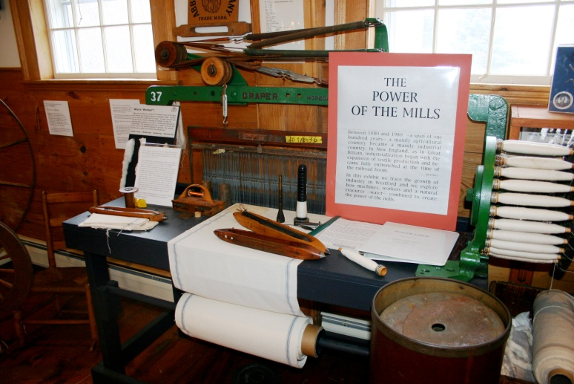

Example

Artifact

And

Display card

Display Card describing the artifact and its importance

Artifact: Loom in a Mill

A rubric is attached to the back of this page. It includes a chart for you to check off as you complete each part of the project. This will help you stay on task and allow you to see what you have left to finish.

All parts of this project should be turned in and organized in to the folder that I provide for you.

Historical Eras to be Covered:

(The chapters are included in parenthesis; the 1st is the yellow book, the 2nd is the red/orange book, 3rd is the blue)

1. River Valley Civilizations (2-3; 2-3; 2-3)
2. Ancient Greece (4; 5; 4)
3. Ancient Rome (5; 6; 5)
4. Ancient Africa & America (6/11; 15/16; 7/11)
5. The Middle Ages (7-8; 13-14; 9-10)
6. The Renaissance & Reformation (13; 17; 12)
7. Exportation (14-15; 19-20; 13)
8. Absolutism (16; 21; 14)
9. Enlightenment Era (17; 22; 17)
10. French Revolution & Napoleon (18; 23; 18)
11. Industrial Revolution (19 & 21; 25, 19 & 20)
12. European Nationalism (22; 24; 19 & 20)
13. European Imperialism (24; 27; 21)
14. World War I (26; 29; 23)
15. Russian Revolution (26; 30; 23)
16. Nationalism around the World (27; 30; 25)
17. Years of Crisis/Between the Wars Era (28; 31; 24)
18. World War II (29; 32; 26)
19. The Cold War (30; 33; 27)
20. The 20th Century (31-33; 34-35; 28-21)
21. The World Today (34; 36; 32)

Final Project Rubric

As you complete each part of your project check it off on the chart below. Read each element carefully to ensure that you are on task and following all directions.

|  |  |  |
| --- | --- | --- |
| Student Check | Teacher Grade | Project Element |
|  |  | |  |  | | --- | --- | | **Check off each column below as you complete each era** | | |  | 1. River Valley Civilizations | |  | 1. Ancient Greece | |  | 1. Ancient Rome | |  | 1. Ancient Africa & America | |  | 1. The Middle Ages | |  | 1. The Renaissance & Reformation | |  | 1. Exportation | |  | 1. Absolutism | |  | 1. Enlightenment Era | |  | 1. French Revolution & Napoleon | |  | 1. Industrial Revolution | |  | 1. European Nationalism | |  | 1. European Imperialism | |  | 1. World War I | |  | 1. Russian Revolution | |  | 1. Nationalism around the World | |  | 1. Years of Crisis/Between the Wars Era/Rise of Totalitarianism | |  | 1. World War II | |  | 1. The Cold War | |  | 1. The 20th Century | |  | 1. The World Today |   Completed research form for the twelve historical eras (**Must be in your own words**) |
|  |  |  |
|  |  | |  |  | | --- | --- | | **Check off each column below as you complete each era** | | |  | 1. River Valley Civilizations | |  | 1. Ancient Greece | |  | 1. Ancient Rome | |  | 1. Ancient Africa & America | |  | 1. The Middle Ages | |  | 1. The Renaissance & Reformation | |  | 1. Exportation | |  | 1. Absolutism | |  | 1. Enlightenment Era | |  | 1. French Revolution & Napoleon | |  | 1. Industrial Revolution | |  | 1. European Nationalism | |  | 1. European Imperialism | |  | 1. World War I | |  | 1. Russian Revolution | |  | 1. Nationalism around the World | |  | 1. Years of Crisis/Between the Wars Era/Rise of Totalitarianism | |  | 1. World War II | |  | 1. The Cold War | |  | 1. The 20th Century | |  | 1. The World Today |   **Two** artifacts are chosen for each historical era.  You must draw at least **ONE** artifact **FROM EACH** historical era |
|  |  | |  |  | | --- | --- | | **Check off each column below as you complete each era** | | |  | 1. River Valley Civilizations | |  | 1. Ancient Greece | |  | 1. Ancient Rome | |  | 1. Ancient Africa & America | |  | 1. The Middle Ages | |  | 1. The Renaissance & Reformation | |  | 1. Exportation | |  | 1. Absolutism | |  | 1. Enlightenment Era | |  | 1. French Revolution & Napoleon | |  | 1. Industrial Revolution | |  | 1. European Nationalism | |  | 1. European Imperialism | |  | 1. World War I | |  | 1. Russian Revolution | |  | 1. Nationalism around the World | |  | 1. Years of Crisis/Between the Wars Era/Rise of Totalitarianism | |  | 1. World War II | |  | 1. The Cold War | |  | 1. The 20th Century | |  | 1. The World Today |   Completed display cards for **each artifact**  **Must include:**  1) Brief description  2) Why it is a good representation for the era (why did you choose it) |
|  |  | All project forms are ORGANIZED NEATLY within the provided project folder |

C:\Users\Rebecca\AppData\Local\Microsoft\Windows\Temporary Internet Files\Content.IE5\BKXZ3S8K\MC900104954[1].wmf

Research Form

On this form, you will record all of your research for the project. YOU ***MUST*** WRITE IN YOUR OWN WORDS

|  |
| --- |
| 1. **River Valley Civilizations (2-3; 2-3; 2-3)**   **What? (What was the event? What were the characteristics of the event?)**  **Who? (Important people and their roles)**  **How? (What happened? What were the major events?)**  **Why? (Why did this happen? Why was it important to World History?)** |
| 1. **Ancient Greece (4; 5; 4)**   **What?**  **Who?**  **How?**  **Why?** |
| 1. **Ancient Rome (5; 6; 5)**   **What?**  **Who?**  **How?**  **Why?** |
| 1. **Ancient Africa & America (6/11; 15/16; 7/11)**   **What?**  **Who?**  **How?**  **Why?** |
| 1. **The Middle Ages (7-8; 13-14; 9-10)**   **What?**  **Who?**  **How?**  **Why?** |
| 1. **The Renaissance & Reformation (13; 17; 12)**   **What?**  **Who?**  **How?**  **Why?** |
| **7. Exportation (14-15; 19-20; 13)**  **What?**  **Who?**  **How?**  **Why?** |
| **8. Absolutism (16; 21; 14)**  **What?**  **Who?**  **How?**  **Why?** |
| **9. Enlightenment Era (17; 22; 17)**  **What?**  **Who?**  **How?**  **Why?** |
| 1. **French Revolution & Napoleon (18; 23; 18)**   **What?**  **Who?**  **How?**  **Why?** |
| 1. **Industrial Revolution (19 & 21; 25, 19 & 20)**   **What?**  **Who?**  **How?**  **Why?** |
| 1. **European Nationalism (22; 24; 19 & 20)**   **What?**  **Who?**  **How?**  **Why?** |
| 1. **European Imperialism (24; 27; 21)**   **What?**  **Who?**  **How?**  **Why?** |
| 1. **World War I (26; 29; 23)**   **What?**  **Who?**  **How?**  **Why?** |
| 1. **Russian Revolution (26; 30; 23)**   **What?**  **Who?**  **How?**  **Why?** |
| 1. **Nationalism around the World (27; 30)**   **What?**  **Who?**  **How?**  **Why?** |
| 1. **Years of Crisis/Between the Wars Era/Rise of Totalitarianism (27; 30; 25)**   **What?**  **Who?**  **How?**  **Why?** |
| 1. **World War II (29; 32; 26)**   **What?**  **Who?**  **How?**  **Why?** |
| 1. **The Cold War (30; 33; 27)**   **What?**  **Who?**  **How?**  **Why?** |
| **The 20th Century (31-33; 34-35; 28-21)**  **What?**  **Who?**  **How?**  **Why?** |
| 1. **The World Today (34; 36; 32)**   **What?**  **Who?**  **How?**  **Why?** |

**Artifacts**

For each historical era, you must come up with **TWO** artifacts. You must draw at least ONE for each era (you will have a total of 12 pictures). Then you should complete the museum display card that explains what the artifact is and why this is a good demonstration of the historical era it represents. This should include its importance.

**River Valley Civilizations**

Artifact 2

Display Card Description:

Artifact 1:

Display Card Description:

**Ancient Greece**

Artifact 2

Display Card Description:

Artifact 1:

Display Card Description:

**Ancient Rome**

Artifact 1:

Display Card Description:

Artifact 2

Display Card Description:

Artifact 1:

Display Card Description:

Artifact 2

Display Card Description:

**Ancient Africa and America**

**The Middle Ages**

Artifact 1:

Display Card Description:

Artifact 2

Display Card Description:

Artifact 1:

Display Card Description:

Artifact 2

Display Card Description:

**The Renaissance and Reformation**

**Explioration**

Artifact 1:

Display Card Description:

Artifact 2

Display Card Description:

Artifact 1:

Display Card Description:

Artifact 2

Display Card Description:

**Absolutism**

**Enlightenment Era**

Artifact 1:

Display Card Description:

Artifact 2

Display Card Description:

Artifact 1:

Display Card Description:

Artifact 2

Display Card Description:

**French Revolution & Napoleon**

**Industrial Revolution**

Artifact 1:

Display Card Description:

Artifact 2

Display Card Description:

Artifact 1:

Display Card Description:

Artifact 2

Display Card Description:

**European Nationalism**

**European Imperialism**

Artifact 2

Display Card Description:

Artifact 1:

Display Card Description:

**World War I**

Artifact 1:

Display Card Description:

Artifact 2

Display Card Description:

**Russian Revolution**

Artifact 1:

Display Card Description:

Artifact 2

Display Card Description:

**Nationalism around the World**

Artifact 1:

Display Card Description:

Artifact 2

Display Card Description:

**Years of Crisis/Between the Wars Era/Rise of Totalitarianism**

Artifact 2

Display Card Description:

Artifact 1:

Display Card Description:

**World War II**

Artifact 2

Display Card Description:

Artifact 1:

Display Card Description:

**The Cold War**

Artifact 1:

Display Card Description:

Artifact 2

Display Card Description:

**The 20th Century**

Artifact 2

Display Card Description:

Artifact 1:

Display Card Description:

**The World Today**

Artifact 2

Display Card Description:

Artifact 1:

Display Card Description: