Name # Period Date
What Is a City-State?
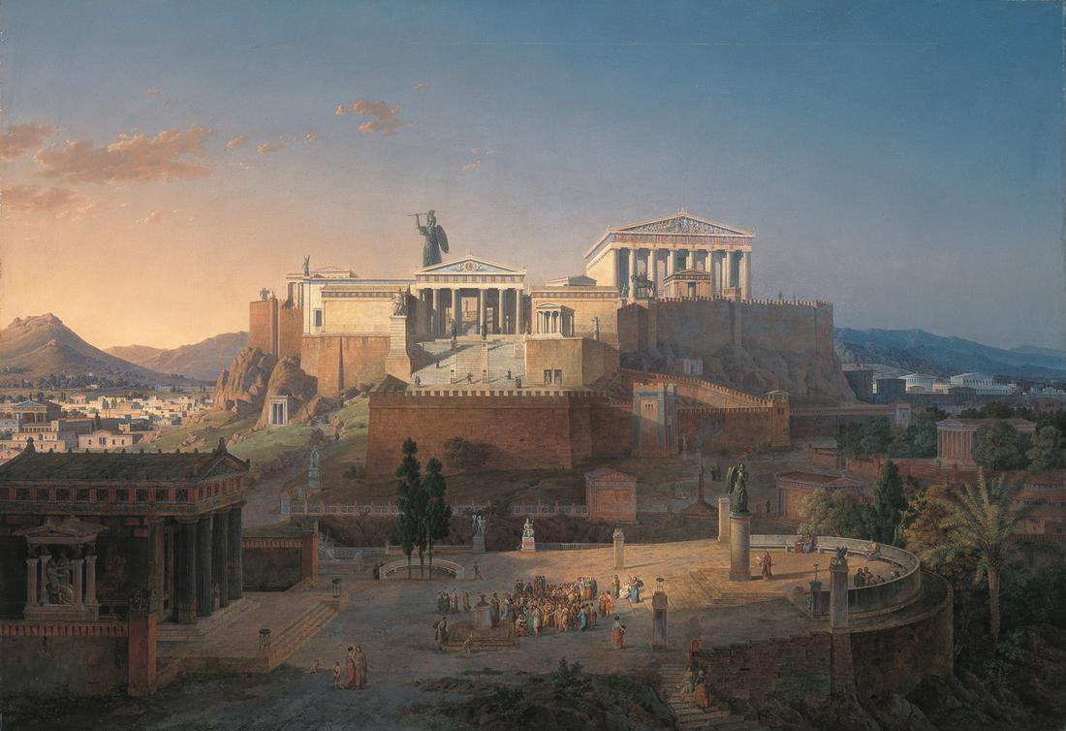
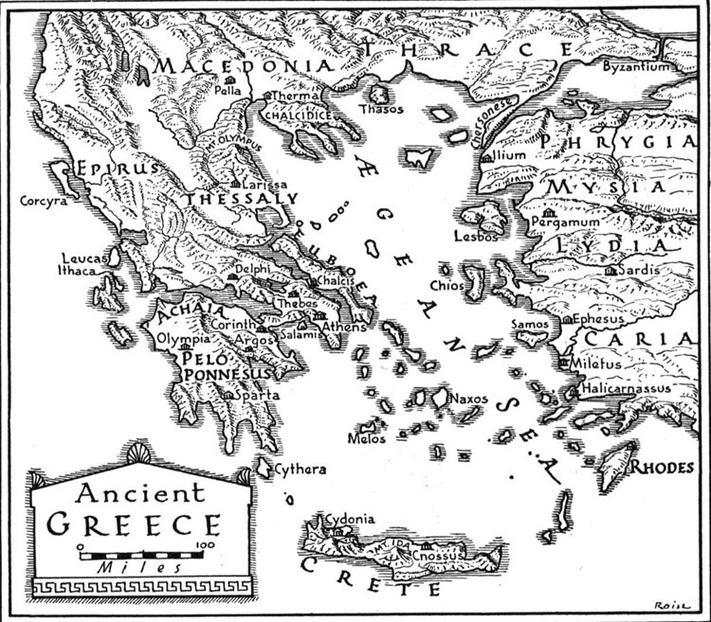
Greece is part of the Balkan Peninsula, which extends southward into the eastern Mediterranean Sea. Mountains divide the peninsula into isolated valleys. Beyond the rugged coast, hundreds of rocky islands spread toward the horizon.
The Greeks who farmed the valleys or settled on the scattered islands did not create a large empire such as that of the Egyptians or Persians. Instead, they built many small city-states, cut off from one another by mountains or water.
While mountains divided Greeks from one another, the seas provided a vital link to the world outside. With its hundreds of bays, the Greek coastline offered safe harbors for ships. The Greeks became skilled sailors and carried cargoes of olive oil, wine, and marble to parts throughout the eastern Mediterranean. They returned not only with grains and metals but also with ideas, which they adapted to their own needs. For example, the Greeks adapted the Phoenician alphabet to meet their needs. The resulting alphabet in turn became the basis for all later Western alphabets.
By 750 B.C., rapid population growth forced many Greeks to leave their own overcrowded valleys. With fertile land limited, the Greeks expanded overseas. Gradually, a scattering of Greek colonies took root all around the Mediterranean from Spain to Egypt. Wherever they traveled, Greek settlers and traders carried their ideas and culture. As their world expanded, the Greeks evolved a unique version of the city-state, which they called the polis. The polis was made up of a major city or town and its surrounding countryside. Athens and Sparta are the best known, but there were also Corinth, Thebes, and others. In contrast to modern nations, each polis, included a city and its surrounding countryside, organized under a single government. Most of the city-states were monarchies ruled by a king. Some of the city-states were oligarchies ruled by the powerful elite members of society. Athens had a very special kind of government called democracy, which meant 'rule of the people.' In Athenian democracy, people voted for the laws that they wanted.
The residents of the polis were bound together not only by a shared political system, but also by common values, language, and religious practices. One common thread between the Greek city-states was that they considered the rights and responsibilities of citizens to be very important. Citizens had privileges and obligations that did not apply to other residents, including women, foreigners, and slaves.
Typically, the city itself was built on two levels. On the top of a hill stood the acropolis, or high city, where you would find great marble temples dedicated to different gods and goddesses. On flatter ground below lay the walled main city with its agora (marketplace), theater, gymnasium, public buildings, and homes.
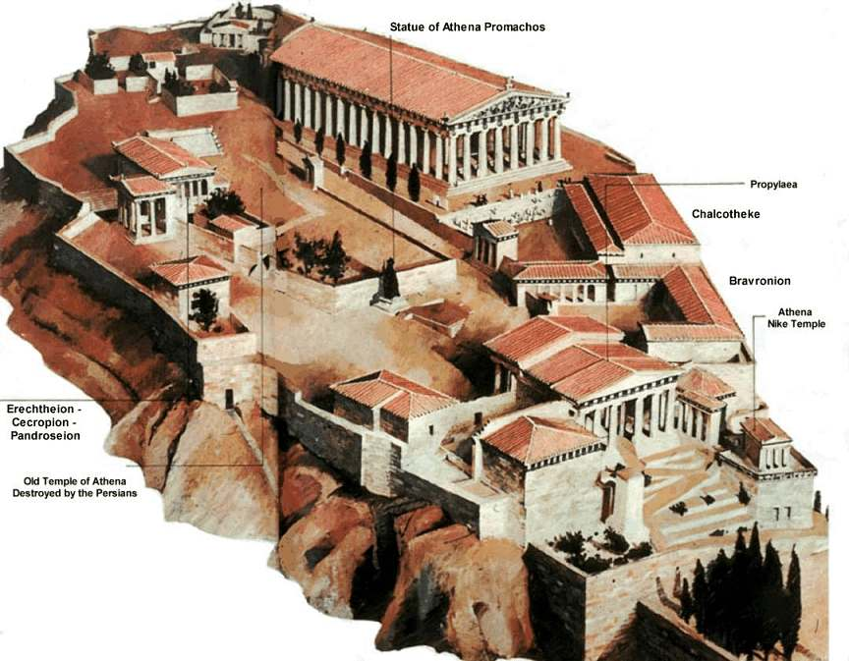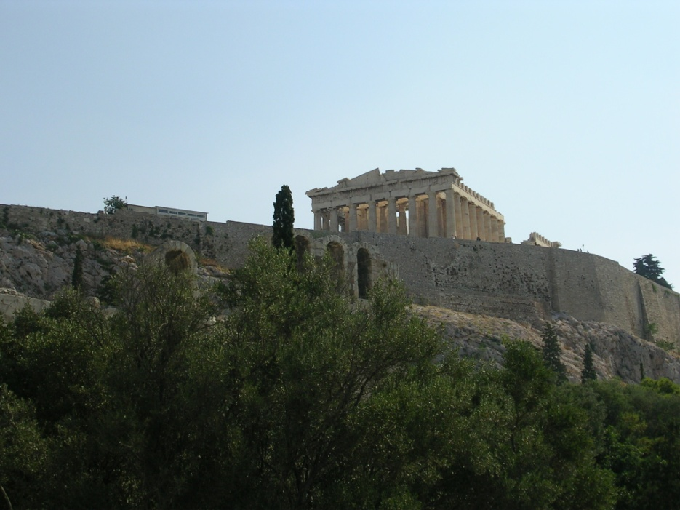
The Acropolis of Athens as taken by the lovely Rebecca Jones © 2005
The population of each city-state was fairly small, which helped the citizens, or free residents, share a sense of responsibility for its triumphs and defeats. In the warm climate of Greece, free men spent much time outdoors in the marketplace, debating issues that affected their lives. The whole community joined in festivals honoring the city’s special god or goddess. The rights of citizens were unequal, however; and male landowners held all the political power.
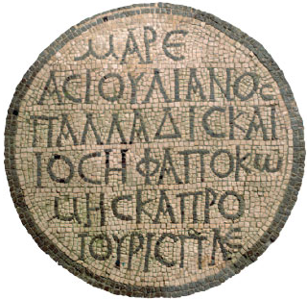
Most ancient Greeks were fiercely loyal to their own city-state, and although they were all Greek, each had its own values and form of government, and residents were intensely loyal to their own city. If asked where they came from, they would reply, "I am from Sparta," "I am a citizen of Athens," or "I come from Thebes." They would not say, "I am from Greece." Each Greek city-state was self-sufficient, sovereign, and independent of the others. Endless rivalries between the different city-states frequently led to war. Despite these divisions, Greeks shared a common culture. They spoke the same language, honored the same ancient heroes, participated in common festivals, and prayed to the same gods.
Greeks honored their gods with temples and festivals, which included processions, sacrifices, feasts, dramatic performances, choral singing, and athletic competitions. To discover the will of the gods, Greeks consulted the oracles, priests or priestesses through whom the gods were thought to speak. Although religion was important, some Greek thinkers came to believe that the universe was regulated not by the will of gods but by natural laws.
As trade and colonies expanded, the Greeks came in contact with people from foreign lands with different languages and customs. Greeks called them barbaroi, people who did not speak Greek, and felt superior to them. The English word barbarian comes from this Greek term. These “barbarians” even included the Phoenicians and Egyptians, from whom the Greeks borrowed important ideas and inventions. This sense of uniqueness and superiority would help the Greeks when they were threatened by the mightiest power in the Mediterranean world—the Persian Empire.
Answer these questions in complete sentences on a separate sheet of paper.
- Explain what a city-state is your own words.
- How did geography influence Greece’s development?
- How were city-states different from one another? What did they have in common?
- When did city-states unite?
- How do you reply when somebody asks you “Where are you from?” (Think: state, city, nation, etc)
- What are some advantages of city-states? Disadvantages?
Government | Monarchy | Oligarchy | Democracy
Advantages
Disadvantages
- What kind of government do you think is the best? Why?
- Make a table of advantages and disadvantages of each government style. (See below)

