The Modern Era: Globalization
Colonialism left new nations “ .”
This table shows how shares of world Gross Domestic Product changed between 1870 and 1998.
Date | India | China | Africa | Japan | Western Europe and U.S.
1870
1913 | 7.6 | 8.9 | 2.7 | 2.6 | 52.6
1950
1973 | 3.1 | 4.6 | 3.3 | 7.7 | 47.7
1998
In 1750, China and India provided 57% of world manufacturing. In 1953, they manufactured only 4% of the world’s goods.
What caused such a dramatic change?

In the 1960s, as the colonized people gained independence, the world-wide split between the North –rich industrial nations—and the South – poor “third world” nations—grew wider.
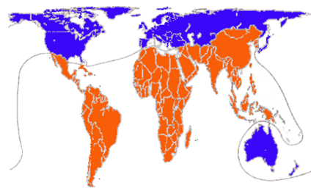
Post WWII, move towards
In theory, free world trade encourages greater economic specialization, more productivity, and greater wealth.

- use of world
- Tariffs ( ) are .
- Businesses can where make more .
- are created.
- People have
In the 1990s, now embraced the majority of the world’s economies.
- Increasing global
  - Faster and
- Rapid growth of social .
- Swift and free flow of across national borders
World population has been rapidly increasing.
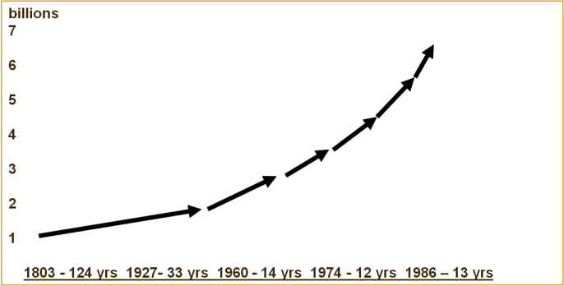
The time it takes to add people grows

Country | Average Life Expectancy
Sweden
France | 78
United States
Bangladesh | 62.8
Botswana | 40.1
Zimbabwe

Life expectancy is rising, but it varies worldwide.
Average life expectancy for the world is years.
- Speed of has dramatically.
- Worldwide is almost

Use this map to summarize how the computer has changed lives around the world

- New allow humans to control like never before
- are being produced, bought, and sold worldwide than ever before.
- Globalization also spreads .
  - Examples from the slide:

- ideas have spread to more countries than ever before.
  - Examples from the slide:

But globalization brings high human costs.
- Although the world’s people are producing more than in wealth, these riches are distributed .
- The continues to increase.
- % get most of the wealth.
- The U.S. owns of this wealth.
- of the world’s people live on less than a day.
- Peasants are forced to as money and wage economies spread.
- Workers without are often left behind.
Gross Domestic Product (GDP) of Selected Countries and Corporations 2002 (Corporations in bold)
Some big multinational corporations have than many
.

Rank | GDP/value added | $trillion
1 | United States
2 | Japan | 4.7
7 | China
 |  | $billion
40 | Malaysia
42 | Philippines | 74.7
43 | Chile | 70.5
44 | Wal-Mart Stores
45 | Pakistan
46 | Peru | 53.5
47 | Algeria | 53.3
48 | Exxon | 57.6
49 | Czech Republic
50 | New Zealand | 50
51 | Bangladesh | 47.1
52 | United Arab Emirates | 46.5
53 | General Motors | 46.2
54 | Hungary | 45.6
55 | Ford Motor
56 | Mitsubishi
57 | Mitsui | 41.3
58 | Nigeria
59 | Citigroup | 39.1

- In poor countries is widespread.
- Some children of ages are working instead of going to school.
  - Involves high energy work, usually 16 hour days, earning between $2-3 a day
Outsourcing is increasing
- In 2003, U.S. information technology jobs.
- An estimated more jobs may move overseas.
- But U.S. loss is a gain for other nations such as:
- Manufacturing and capital flows to the areas of the world where they can
- The following keep business away:

  - Strong labor unions
  - High wages
  - Environment protection laws
  - Unstable governments

Environmental Problems
- forests.
- burning fossil .
- producing industrial and consumer .
- Growing to the environment affect people

Lots of the people question globalization. Why?

Globalization involves contradictions.
- industry but gap between rich and poor?
- Lots of pluralism but people becoming “homogenized?” (losing culture, becoming the same)
- Increasing but small communities banding more together?
- in industrialized nations but great in other countries?

Some people believe that globalization is “cultural imperialism” AKA culture, particularly American culture, is taking over other countries around the world.
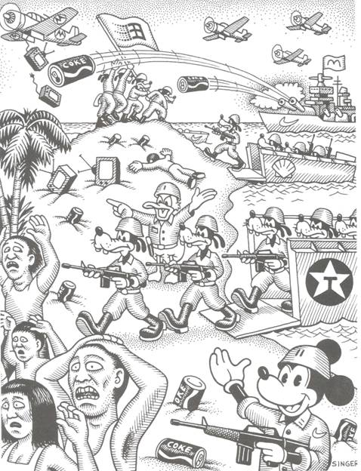
Can you interpret how this cartoon depicts the idea of “cultural imperialism?”

People respond to globalization differently.
- wholeheartedly it.
- seek to their
- fight for more
- turn to .
- turn
- try to it for human .
Terrorism has ushered in a new global threat.
- military strategies and are often against suicide attacks.
- communicate and spread their ideologies .
- groups may have in many nations.
  - In , the United States government adopted of intervention as part of a .
  - 2002 – U.S. forces invaded to topple the government of the , which was cooperating with international terrorists.
  - 2003 – U.S. forces invaded to overthrow the government of . The U.S. accused him of terrorism.
- In this new era, will the US act as democratic leader, the supreme world power, as an empire?
  - owns about of the world’s .
  - working to create institutions in Afghanistan, Iraq, and other countries.
  - has force equal to the next countries combined.
  - striving to be a of for the world.
  - maintains military bases, valued at $ billion, with military personnel in nations.
- Do you believe that one person can make a difference? Why or why not?

