Name # Class Period Date
Study Guide Ancient Civilizations Test
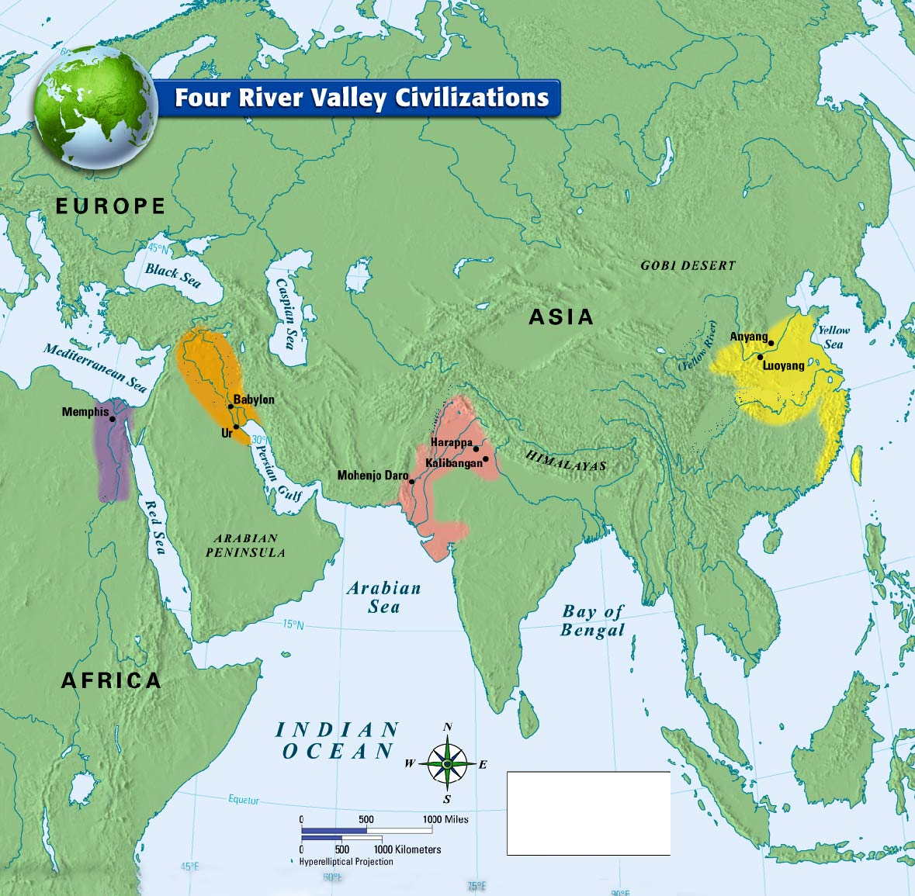
- Label Egypt, Mesopotamia, Indus, and China on the map below.

Fill in the chart
 | Mesopotamia | Egypt | Indus | China
Cities
Rivers
Writing
Important Facts

- What is the Neolithic Revolution?
- What were the achievements of Qin ShiHuangdi?
- Which discovery allowed us to translate hieroglyphics?
- What is Pre-History?
- What was the change of hunting and gathering to farming called?

- What do archeologists use to learn about the lives of humans?

- What is an artifact?
- What is a fossil?
- What are the eight features of civilization?
- What is Hammurabi’s Code?
- Where were the Jew enslaved?
- What is the Caste System?

Fill in the chart below
 | Hinduism | Judaism | Buddhism
Founder & Place it originated
Important Books or texts
Number (and names) of gods
Basic Beliefs

