Name________________________________#_______Date_________________Class_________
Luther Viewing Guide
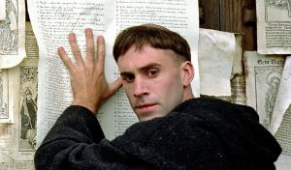  Martin Luther | HRE Charles V | 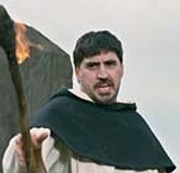  John Tetzel | Pope Leo X | Katharina von Bora | 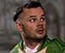Ulrick
Frederick of Saxony | 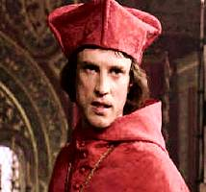  Aleander | 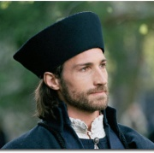  Spalatin | 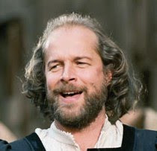Carlstadt | Johann von Staupitz | Cardinal Cajetan
- Why is Martin Luther’s father angry with him at the beginning of the movie?

- Why does Luther think he cannot be a priest?

- What kind of God does Luther want? Who does the priest tell Luther to turn to?

- Where does Luther go on his journey?

- Name two problems Luther encounters in Rome that tells his church “father” about.

- Why did the people in Wittenberg treat Luther as if he was a “leper”?

- Where does Luther’s teacher claim that salvation comes from? Where does Luther say it comes from?

- What does Luther do to upset the people in regards to the boy who committed suicide?

- Did Luther buy an indulgence in Rome? What did it “do”?

- Describe the character of John Tetzel.

- What was Luther’s number one complaint against the Catholic Church?

- How did word spread about the 95 Theses?

- What was Luther threatened with?

- Does Luther recant? What does he say was his reason?

- What happens when Luther does not recant to his church “father”?

- What did the Catholic Church do with the written works of Luther? What does Luther do in return?

- When Luther doesn’t recant in Worms, he wants proof. Where does this “proof” come from for him?

- What happens to Luther on his journey back from Worms?

- What did the peasants who supported Luther do?

- How many peasants died?

- What language does Luther translate the New Testament into?

- Who does Luther marry?

- What did the princes deny the emperor?

- How many people today worship the Christian God under the reforms of Luther?

When you are finished with the movie, respond in a short paragraph to the following questions:
- How were Luther’s teachings different from that of the Catholic Church?

- Describe how Luther’s teachings spread throughout Europe.

- Explain how the Protestant Reformation weakened the Roman Catholic Church.

