Babylonian king Nebuchadnezzar attacks Jerusalem and destroys Solomon’s temple. Known as the Babylonian Captivity or the Exile.
The Hebrews wander in the desert of 40 years, and then settle in Canaan.
David is succeeded by his son, Solomon. Solomon builds a temple to God in Jerusalem.
The kingdom is divided into two: Israel in the north and Judah in the South.
God makes a covenant with Abraham, promising to protect him in return for obedience.
King David establishes the capital city of Jerusalem.
Hebrews untie and form the Kingdom of Israel under King Saul.
Time of the Judges: In times of emergency judges were called to lead the 12 tribes of Israel.
Descendants of Abraham move to Egypt.
The Exodus: Moses leads the people out of Egypt and makes a New Covenant with them.
The Persians under Cyrus the Great conquers Babylon and allow the Hebrews to rebuild the temple.
Abraham is chosen by God to be the father of the Hebrew people and commands him to move out of Ur in Mesopotamia to the “promised land” of Canaan.
The Assyrians conquer Israel and Judah.

Judaism Timeline
On a sheet of poster paper, create a timeline by cutting out the events and putting them in chronological order. NOT ALL EVENTS WILL HAVE A SPECIFIC DATE. If a date is listed, you should record it on your timeline. You must draw at least two pictures that represent Judaism. When you have finished the time line, answer the following questions either on the bottom of the timeline or on the back. YOU SHOULD ANSWER THEM IN COMPLETE SENTENCES. Then answer the questions that follow the maps.
- What is the Torah and why is it important? Besides Jews, what other religious group uses the Torah.
- How were the Jews different from other religious groups in Mesopotamia or the ancient world?
- What does God give to Moses at the time of the New Covenant?
- What is taught by Hebrew Law? What is the purpose of the prophets?
- What were the main problems faced by the Hebrews in their early history?
Modern Middle East
Saudi Arabia
Caspian Sea
Mediterranean Sea
Iran
Egypt

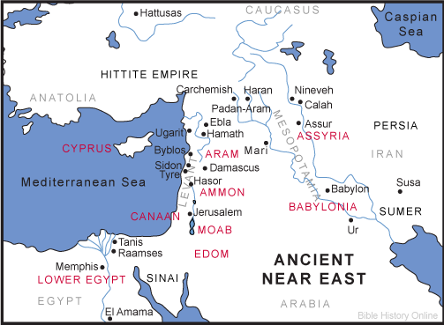
Ancient Middle East

- What two nations in the Modern Middle East used to be Persia and Sumer?
- What nation in the Modern Middle East is the Hittite Empire?
- What nation has the same name in the Modern and Ancient Maps?
- What nation on the Modern map is Canaan on the Ancient Map?

