Foundations of Civilization
Part 1: Vocabulary
Directions: In the 2nd box you will find the definition of the vocabulary. Figure out which word matches with the definition, and then put the definition in your own words. Finally, in the last column draw a picture that represents that word.

Vocabulary Word | Book Definition | Your Definition | Picture
 | An object made by humans
 | The study of the origins and development of people and their societies
 | Someone who studies the past
 | A society’s way of life
 | The study of past cultures through their remains
 | Skills and tools people use to meet their basic needs and wants
 | The period of time before people invented writing

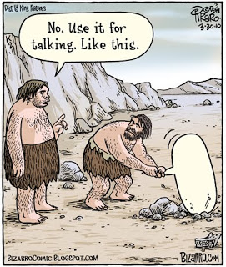
Part 2: Chapter Summary and Main Ideas
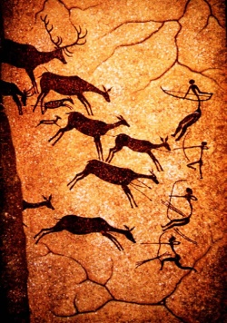
Writing was invented 5000 years ago. The period before that is known as prehistory. Several kinds of jobs involved studying human history—before and after writing was invented.
Historians learn about the past from artifacts. These include clothing, coins, artwork, and tombstones. They also study written materials, such as letters or tax records. Historians try to figure out how reliable this evidence is. They use it to explain why an event, such as a war, took place. What they learn about the past helps us understand events today.
Anthropology is the study of humans and their societies. Some anthropologists study human bones. They want to understand how humans have changed. Others study cultures, or people’s ways of life. Archaeology is part of anthropology. It is the study of past people and cultures through artifacts such as tools, weapons, and pottery. Archaeologists use modern tools such as computers. A method, or techniques, for measuring radioactivity (energy waves) helps them figure out the age of objects.
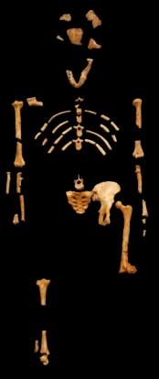
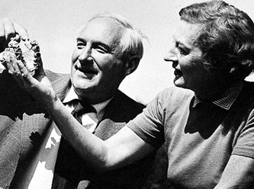
Before the 1950s, anthropologists knew little about early humans. Anthropologists Mary and Louis Leakey searched for clues in East Africa at a canyon called Olduvai George. There they found many ancient stone tools. The tools showed that whoever made them had the technology, or skills and tools, to survive. Then, in 1959, after more than 20 years of searching, Mary Leakey found the skull of an early hominid. In 1974, anthropologist Donald Johnson found many pieces of a hominid, or early human, skeleton that anthropologists nicknamed “Lucy.” She was at least 3 million years old.
Discoveries like these suggest that there were many different hominid groups alive in the past. These included Homo habilis—who were the first to make stone tools—and Homo erectus—who are thought to be the first group to use fire and migrate out of Africa. Two groups of Homo sapiens arose. One of the groups, called Neanderthals, disappeared 50,000 to 30,000 years ago. The only hominids left on Earth then were early modern humans.

- What kinds of evidence do historians use to study the past?
- What types of evidence do anthropologists and archaeologists study to learn about prehistory?
- Why were the Leakeys and Donald Johnson important?
- On which landmass (continent) did the first hominids live?

