Name # Class Period Date
Empires in East Asia
 | China (12.1) | Japan (12.4) | SE Asia (12.5) | Korea (12.5)
Geography & Trade

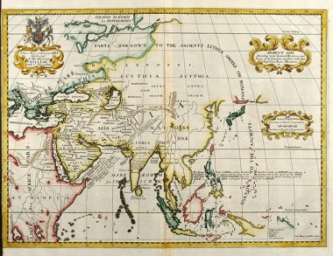

Politics
(Leaders, Dynasties, government, etc)
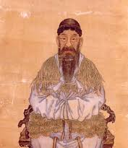

Culture
(art, religion, inventions, literature, etc)

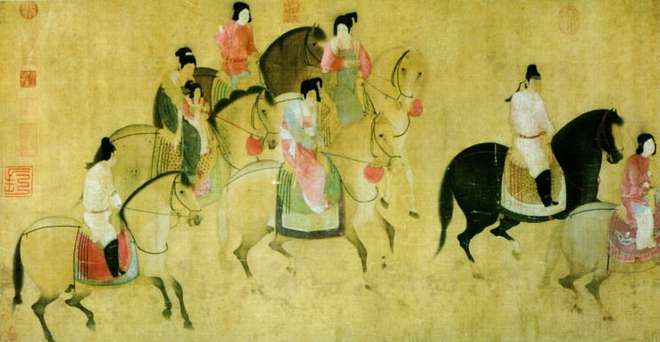
Main Ideas
Tang & Song China
- How did the Tang benefit from the accomplishments of the Sui?

- Describe the urban social classes that emerged during Tang and Song period.

- What impact did inventions of Tang and Song China have?

Feudal Powers of Japan
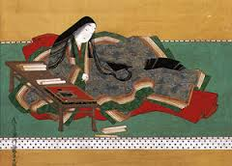
- Why were Japanese missions to Tang China so important?

- What purpose did the samurai serve?

- How did feudalism develop in Japan?

- Was the rise of the shogun beneficial or detrimental to Japan? Explain your answer

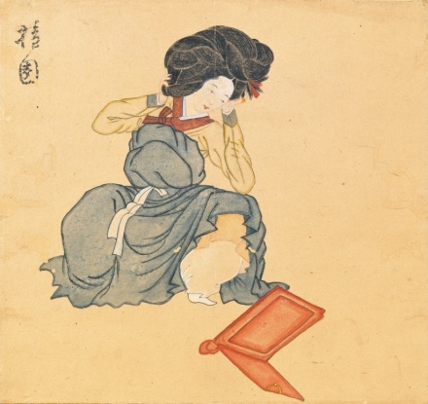
Kingdoms of SE Asia & Korea
- Describe the two sources of prosperity for Southeast Asian empires.

- What were the major accomplishments of the Koryu Dynasty?

- In what ways did the cultural development of Vietnam resemble that of Korea?

