Name Class Period Date

**Hinduism and Buddhism**. You can find the answers to the questions below starting on page 76

Part 1: Hinduism

1. In what country did Hinduism and Buddhism both begin?

1. What makes Hinduism different from most major religions?

1. What does the proverb “God is one, but wise people know it by many names,” mean to the Hindus?

1. Who are the most important Hindu gods?

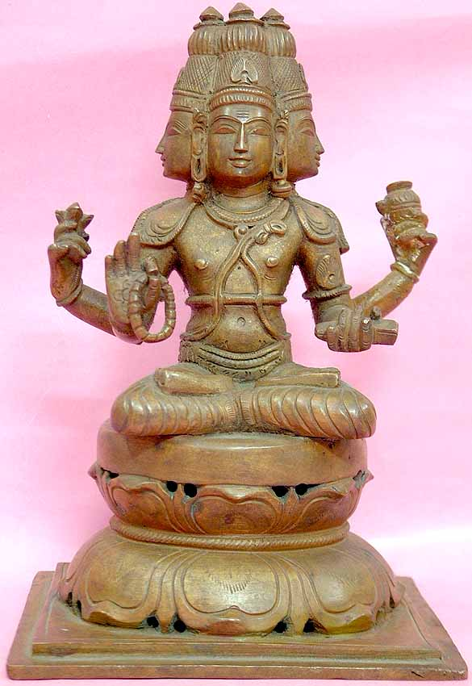 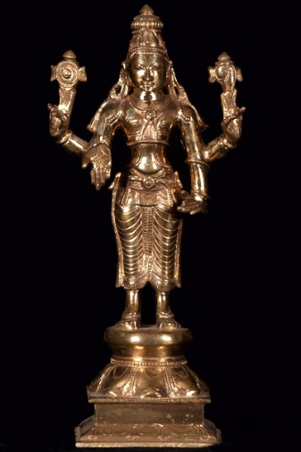 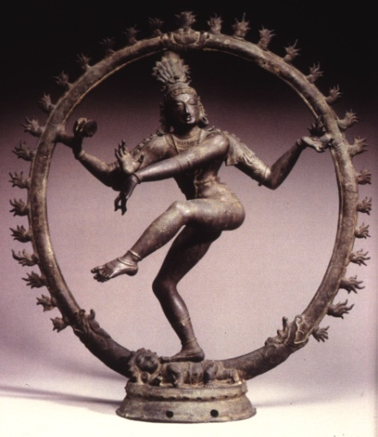

1. What are the Vedas, Upanishads, and the *Bhagavad-Gita*?

1. Write **ONE** sentence using the words *atman*, *moksha*, and *reincarnation* which explains the goal of life for Hindus.
2. What is Karma? What role does it play in how you are reincarnated?

1. What are the principles of *dharma* and *ahimsa*?

1. To Hindus, _________________________________are aspects of _____________________ and therefore deserve to be _____________________________________.

Part 2: The Caste System

1. What are castes?

1. Why is it seen as important to follow the rules of your caste?

1. Who are the “untouchables? Why do they have that name?

1. Summarize how the caste system gave society a sense of order.

Part 3: Buddhism

1. Who was Siddhartha Gautama? What was his childhood like?

1. How did Siddhartha’s life change at 29? What did he set out to discover?

1. What does Buddha mean?

1. What are the Four Noble Truths?

1. What is the “Eightfold Path”?

1. What is the goal of Buddhism?

Use the Venn Diagram below to compare and contrast Hinduism and Buddhism.

Hinduism

Both

Buddhism

Part 4: Buddhism Spreads

Using the maps on page 81 as a guide, label India, Burma, Southeast Asia, China, Mongolia, Korea, and Japan on the map below. Then draw arrows to show the spread of Buddhism in Asia. Finally, choose one color to shade in the areas where Buddhism exists in Modern Asia (do not differentiate between Theravada and Mahayana or Tibetan Mahayana).

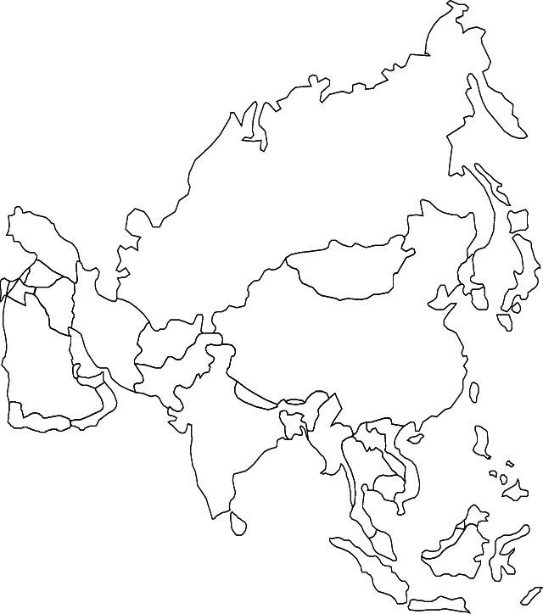

1. What did Buddha’s followers do with his teachings after he died?

1. How was the Mahayana sect different from the Theravada sect?