Differences between the Italian and Northern Renaissance
The Renaissance was a period of great cultural and technological changes which swept Europe from the end of the 13th century. It was integral in developing Europe into a powerhouse. Although, each part of Europe was subjected to different changes, there were two primary renaissances which were most notable. They were the Italian and the Northern renaissance. Both of these renaissances had a profound impact on Europe. But they also had some typical differences among them and each was unique in its own way.
Italian Renaissance
The opening phase of renaissance was started by the Italian renaissance. It was a period of great cultural changes and achievement throughout Europe. It spanned from the end of the 13th century up to about the 1600’s. It marked the transition of Europe from the medieval period to the Early Modern Europe. The term renaissance is in essence a modern one that came into currency in the nineteenth century, in the work of historians such as Jacob Burckhardt.
Although the origins of a movement that was confined largely to the literate culture of intellectual endeavor and patronage can be traced to the earlier part of the 14th century, many aspects of Italian culture and society remained largely medieval; the Renaissance did not come into full swing until the end of the century. The word renaissance (Rinascimento in Italian) means “rebirth”, and the era is best known for the renewed interest in the culture of classical antiquity after the period that Renaissance humanists labeled the Dark Ages. These changes, while significant, were concentrated in the elite, and for the vast majority of the population life was little changed from the Middle Ages.
The Italian Renaissance is best known for its cultural achievements. Italian Renaissance literature includes such figures as the humanists Petrarch (best known for the sonnets of The Canzoniere), Boccaccio (best known for the tales of The Decameron) and other renaissance humanists such as Poliziano, Marsilio Ficino, Lorenzo Valla, Aldo Manuzio, Poggio Bracciolini, the renaissance epic authors Castiglione (The Book of the Courtier), Ludovico Ariosto (Orlando Furioso) and Torquato Tasso (Jerusalem Delivered), and prose authors such as Machiavelli (The Prince). Italian Renaissance painting exercised a dominant influence on Western painting for centuries afterwards, with artists such as Michelangelo, Raphael, Botticelli, Titian, and Leonardo da Vinci, and the same is true for architecture, with Andrea Palladio and works such as Florence Cathedral and St. Peter's Basilica in Rome: see Renaissance architecture. At the same time, some present-day historians also see the era as one of economic regression and of little progress in science, which made its great leaps forward among Protestant culture in the seventeenth century.
Northern Renaissance
The Northern Renaissance is the term used to describe the Renaissance in northern Europe, or more broadly in Europe outside Italy. Before 1450 Italian Renaissance humanism had little influence outside Italy. From the late 15th century the ideas spread around Europe. The resulting German Renaissance, French Renaissance, English Renaissance, Renaissance in the Netherlands, Polish Renaissance and other national and localized movements with different characteristics and strengths.
In France, King Francis I imported Italian art, commissioned Italian artists (including Leonardo da Vinci), and built grand palaces at great expense, beginning the French Renaissance. Trade and commerce in cities like Bruges in the 15th century and Antwerp in the 16th increased cultural exchange between Italy and the Low Countries, however in art, and especially architecture, late Gothic influences remained present until the arrival of Baroque even as painters increasingly drew on Italian models.
Universities and the printed book helped spread the spirit of the age spread through France, the Low Countries and the Holy Roman Empire, and then to Scandinavia and finally Britain by the late 16th century. Writers and humanists such as Rabelais, Pierre de Ronsard and Desiderius Erasmus were greatly influenced by the Italian Renaissance model and were part of the same intellectual movement. During the English Renaissance (which overlapped with the Elizabethan era) writers such as William Shakespeare and Christopher Marlowe composed works of lasting influence. The Renaissance was brought to Poland directly from Italy by artists from Florence and the Low Countries, starting the Polish Renaissance.
Differences between Italian and Northern Renaissance
In some areas the Northern Renaissance was distinct from the Italian Renaissance in its centralization of political power. While Italy and Germany were dominated by independent city-states, parts of central and Western Europe began emerging as nation-states. The Northern Renaissance was also closely linked to the Protestant Reformation and the long series of internal and external conflicts between various Protestant groups and the Roman Catholic Church had lasting effects, such as the division of the Netherlands.
Bascially, the Northern Renaissance took place in areas of Eastern Europe (like the Netherlands). During this time, there was an emphasis on daily life--the lives of peasants. A greater emphasis was put on living a pious, simple life. Therefore, artists like Peter Brugal the elder painted pictures such as "Haymaking." It showed regular peasants carrying out their normal everyday tasks. Keep in mind that the Northern Renaissance came much later.
The Italian Renaissance, on the other hand, focused more on the wealthy class (aristocracy). Paintings were elaborate, detailed, and showed how wealthy and powerful people were. This was because alot of trade was going on during the time of the Itailian Renaissance, especially in the Mediterranean. Therefore, individuals were becoming very wealthy, and thus gaining poltical influence. Also, the Itailain Renaissance focused on religion--Roman Catholicism. Popes were wealthy, king-like figures in society and they were often painted in elaborate settings. Greek-Roman revival was very important. Often, paintings reflected themes of the Classical times, and some artists nearly copied the forms of ancient Greek statues and artwork. Painting like the “Last Judgement” showed a lot of Italian Renaissance themes- Humanism (the focus of the individual, emphasis on anatomy), Greek-Roman revival, and religion.
The main differences between the Italian and Northern Renaissance can be tabled as follows-
 | ITALIAN RENAISSANCE | NORTHERN RENAISSANCE
Subject Matter: | Classical mythology, religious scenes | Domestic interiors, portraits, religious scenes
Style | Symmetrical, balanced, good sense of mass, linear perspective | Attention to surface detail, naturalism
Known for: | Figures with mass and volume, knowledge of underlying anatomy | Minute surface detail
Media: | Fresco, tempera, oil | Oil on panel
Example | Michelangelo, Creation of Adam from the Sistine Chapel ceiling | Jan van Eyck, Arnolfini Wedding

Apart from the differences in the above table and the obvious geographical difference, there were some other significant differences between the Italian Renaissance and the Northern Renaissance. For one thing, the north held on to Gothic (or "Middle Ages") art and architecture with a tighter, longer grip than did Italy. (Architecture, in particular, remained Gothic until well into the 16th century.) This isn't to say that art wasn't changing in the north - in many instances it kept pace with Italian doings. The Northern Renaissance artists, however, were scattered about and few in number initially (very unlike their Italian counterparts).
The north had fewer centers of free commerce than did Italy. Italy, had numerous Duchies and Republics which gave rise to a wealthy merchant class that often spent considerable funds on art. This wasn't the case in the north. In fact, the only notable similarity between northern Europe and, say, a place like Florence, lay in the Duchy of Burgundy.
Burgundy, until 1477, encompassed a territory from present-day middle France northward (in an arc) to the sea, and included Flanders (in modern Belgium) and parts of the current Netherlands. It was the only individual entity standing between France and the enormous Holy Roman Empire. Its Dukes, during the last 100 years it existed, were given monikers of "the Good," "the Fearless" and "the Bold" (although apparently the last "Bold" Duke wasn't quite bold enough, as Burgundy was absorbed by both France and the Holy Roman Empire at the end of his reign...but, I digress...)
The Burgundian Dukes were excellent patrons of the arts, but the art they sponsored was different from that of their Italian counterparts. Their interests were along the lines of illuminated manuscripts, tapestries and furnishings (they owned quite a few castles, these Dukes). Things were different in Italy, where patrons were more keen on paintings, sculpture and architecture.
In the broader scheme of things, the social changes in Italy were inspired, as we've seen, by Humanism. Italian artists, writers and philosophers were driven to study Classical antiquity and explore man's supposed capacity for rational choice. They believed that Humanism led to more dignified and worthy humans. In the north (possibly in part because the north did not have works of antiquity from which to learn), change was brought about by a different rationale. Thinking minds in the north were more concerned with religious reform, feeling that Rome (from whom they were physically distanced) had strayed too far from Christian values. In fact, as northern Europe became more openly rebellious over the authority of the Church, art took a decidedly secular turn.
Additionally, Renaissance artists in the north took a different approach to composition than did Italian artists. Where an Italian artist was apt to consider scientific principles behind composition (i.e., proportion, anatomy, perspective) during the Renaissance, northern artists were more concerned with what their art looked like. Color was of key importance, above and beyond form. And the more detail a northern artist could cram into a piece, the happier he was. Close inspection of Northern Renaissance paintings will show the viewer numerous instances where individual hairs have been carefully rendered, along with every single object in the room including the artist himself, distantly inverted in a background mirror.
Finally, it's important to note that northern Europe enjoys different geophysical conditions than does (most of) Italy. For example, there are lots of stained glass windows in northern Europe partly for the practical reason that people living there have more need of barriers against the elements.
Italy, during the Renaissance (and, of course, beyond) produced some fabulous egg tempera paintings and frescoes, along with glorious marble statuary. There's an excellent reason the north isn't known for its frescoes: The climate isn't conducive to curing them. The north developed the chemistry of oil paints for this very reason. Artists needed a medium that would dry (however slowly) and last. Italy produced marble sculptures because, by gum, it has marble quarries. You'll note that Northern Renaissance sculpture is, by and large, worked in wood.

Questions:
- What does Renaissance mean?
- Why were the cultural achievements of the Italian Renaissance important?
- Where did the Northern Renaissance take place? How did it get these places?
- What social class was the emphasis of the Northern Renaissance?
- How was the Italian Renaissance different from the Northern?
- What inspired the social changes in Italy?
- Why was Northern art more secular (non-religious)?

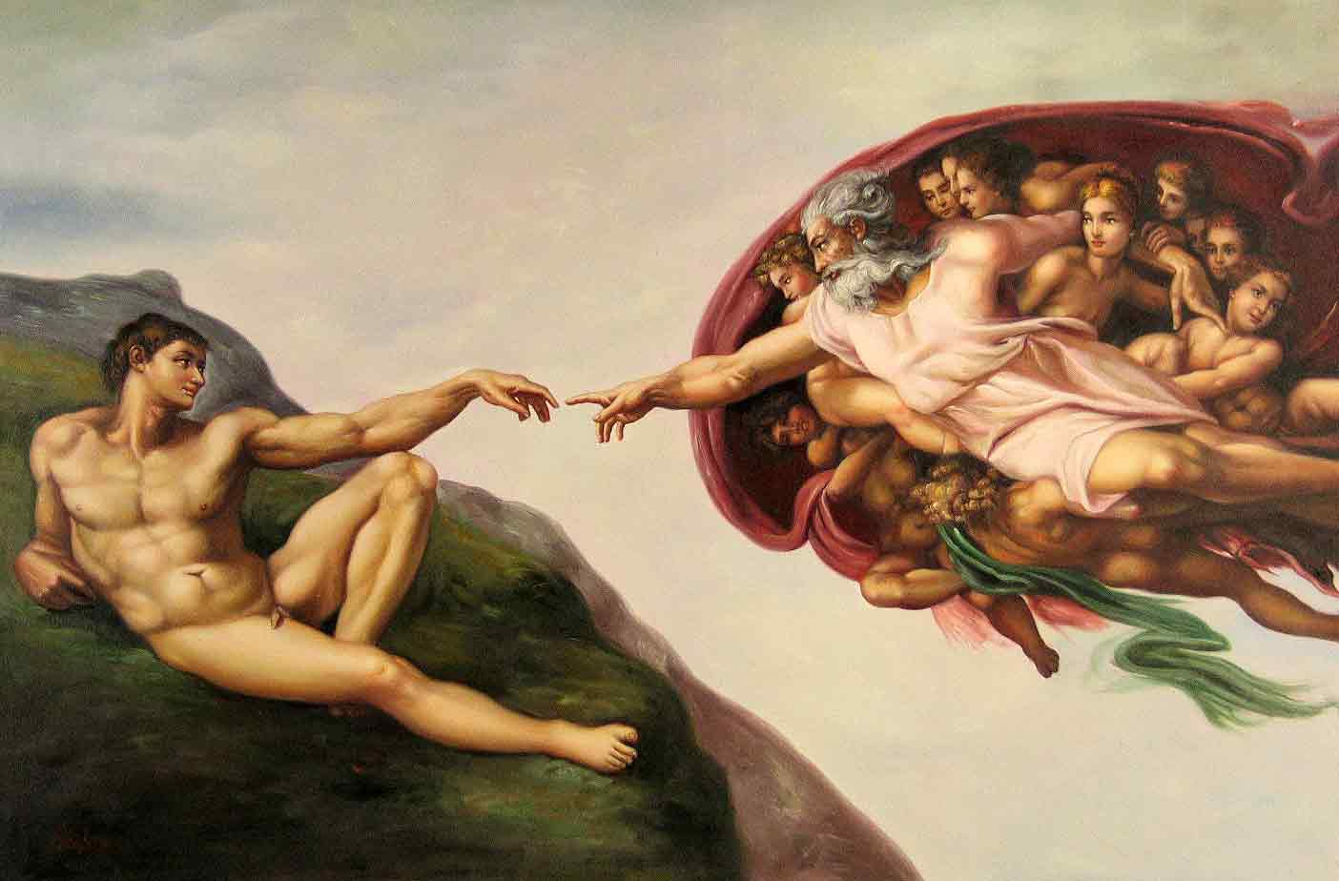
Art: For each of the following works of art, identify if you think they are Northern or Italian Renaissance based on your reading. Be sure to EXPLAIN WHY you think so.

